Celebrating St Columbanus, the sixth century monk, in the many places where his memory remains alive

Denis Nulty

09 July 2025, The Tablet

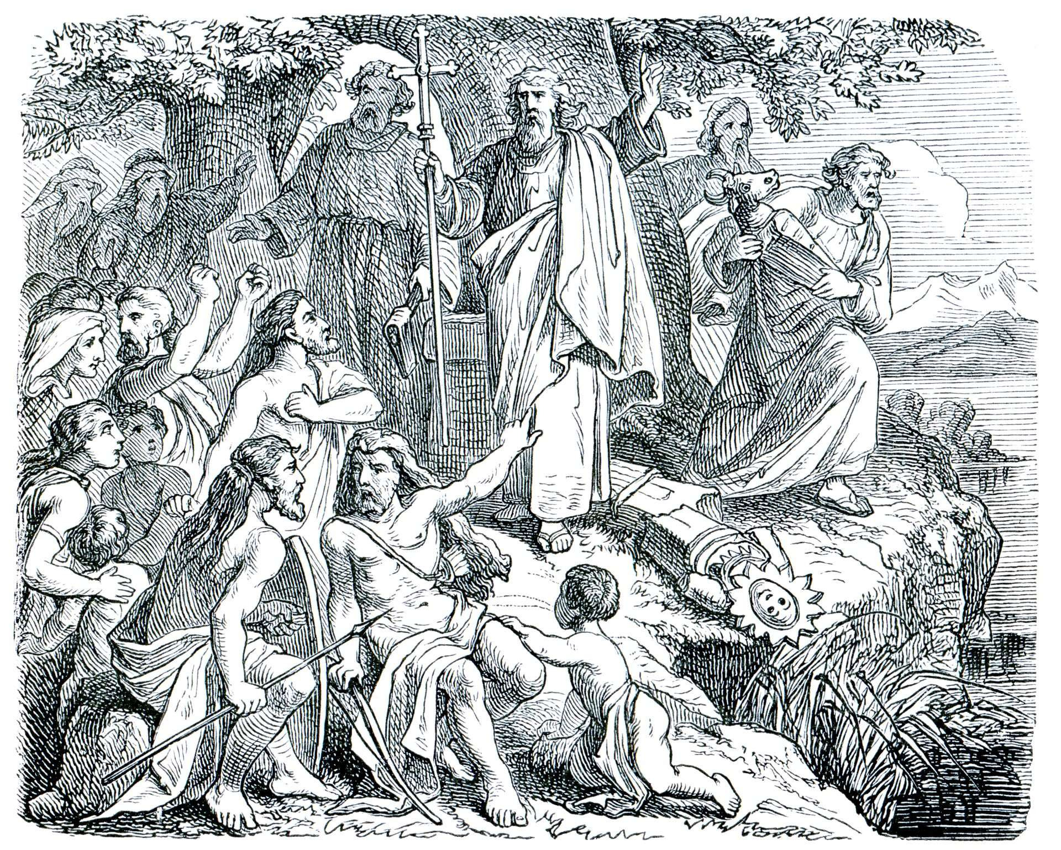

Engravings that depicts Saint Columbanus from the book History of the Church, 1880

Kohl-Illustration / Alamy

Columbanus saw himself as undoubtedly a “*Peregrinus pro Christo*” (a pilgrim for Christ). Going on a Camino, going on a pilgrimage, allows us to become pilgrims, to step back from the familiar and give ourselves totally into the hands of the Lord. Columbanus had respect for the terrain on which he journeyed

“*Is bothar currach é an saol, fairsing do dhaoine áirithe agus cúag do dhaoine eile*” St. Columbanus wrote in his fifth sermon, it translates as “*Life is a real road, broad for some and narrow for others*”. So reads the message, as you reach the Columban Way Cairn at the Nine Stones on the Blackstairs Mountains. This point marks the start of *Turas Columbanus*, *Via Columbani* or the Columban Way. In essence it is a 6,000km Camino. A journey from his birthplace near Myshall, County Carlow, to Bangor, County Down where he spent most of his adult formative years, before continuing his journey across mainland Europe, eventually establishing monastic foundations in places like Annegray, Luxeuil, Fontaines, Bregenz and Bobbio.

Columbanus saw himself as undoubtedly a “*Peregrinus pro Christo*” (a pilgrim for Christ). Going on a Camino, going on a pilgrimage, allows us to become pilgrims, to step back from the familiar and give ourselves totally into the hands of the Lord. Columbanus had respect for the terrain on which he journeyed. He was on sacred ground. He was walking in the footsteps of Christ and in walking the Columban Way, we too are invited to walk in the footsteps of this sixth century monk.

Myshall lies at the foot of the northern slopes of the Blackstairs Mountains. It is the birth place of St. Finian, the great tutor to the Saints of Ireland, and also the birth place of St. Columbanus. In the official announcement at the end of the last Columbanus Day in 2024, designating Carlow as the host venue for the XXVI iteration, the citation invited all to “*go to where St. Columbanus was born, where his life-long journey began and which has left an indelible mark on the history of Europe and on us Europeans, even today*”.

And we find ourselves in Myshall, on the side of Mount Leinster, in Kildare and Leighlin Diocese. The rationale behind these Columbanus Day Celebrations is to celebrate the story of the sixth century monk in countries and regions where his memory remains alive. The Columban Charter of Partnership was signed in St. Gallen in July 2023. Its aim is to develop and promote pilgrimage routes; to promote cultural activities between the different countries; to work with scientists, scholars and teachers to impart a broader understanding of the life, heritage and spirituality of Columbanus and his contemporaries; to respect creation and biodiversity in all activities and to further develop the Columban Way. The countries, who are signatory to the Charter include Ireland, Britain, France, Luxembourg, Germany, Switzerland, Austria, Liechtenstein and Italy. Hosting the Columbanus Day allows the particular country and diocese to fulfil many of the aims and objectives of the Charter.

So if you want to hear about how Ireland gave birth to Europe, come to Carlow County Museum on Friday 11 July. If you want to understand deeper the impact our everyday choices make on biodiversity, come to Carlow College afterwards. If you want to pray in the presence of a specially gifted relic of St. Columbanus, come to the Adelaide Church and the Church of the Exaltation of the Cross, both in Myshall.

If you feel up to walking a portion of the Columban Way, come to the Nine Stones on Saturday morning, 12 July. If you want to hear about how Columbanus is essentially the ‘*Man from Myshall*’, listen to former President Mary McAleese in Myshall. If you want to enjoy a special concert in honour of the Columbanus Day, join us in the Cathedral of the Assumption, Carlow on Saturday evening for ‘*Praise Resounds – Echoes of the past, hope for the future*’.

The weekend culminates with the celebration of Mass in the Cathedral at 10.30am on Sunday 13 July when next year’s host diocese will be announced. All are invited to come to Carlow for the XXVI Columbanus Celebrations. Come to the place where Columbanus was born, and unpack some of his story which has given Europe its Christian roots.

*Denis Nulty is Bishop of Kildare and Leighlin*