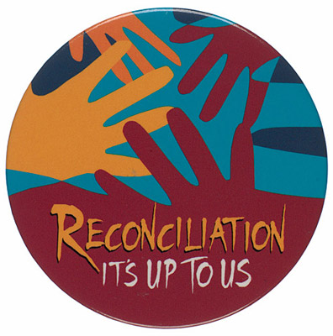
Diocesan
Penitential
Service
in Preparation
for
The Sacrament of First Reconciliation

Cathedral of the Assumption, Carlow
18 March 2021

Gathering Song: I’m Sorry’ (Mary Amond O’Brien)

Words of Welcome: Bishop Denis

Sign of the Cross & Greeting:
We begin our time of prayer together by marking ourselves with the sign of our faith, ‘In the name of the Father and of the Son and of the Holy Spirit.’

Grace to you and peace from God our Father and the Lord Jesus Christ.
Response: And with your spirit

Opening Prayer:
Gracious God,
we come before you
in need of your mercy and
confident of your love and forgiveness
Touch our hearts and convert us to yourself.
Where sin has divided,
may your love make one again;
where sin has brought weakness,
may your power heal and strengthen;
Give us a new heart to love you,
so that our lives may reflect the image of your Son.
Heal us that we may receive your grace
and bring your love to our homes and world.
We ask this through Christ our Lord. Amen.
Liturgy of the Word
1 John 4:7-12
Dear friends, let us love one another, because love comes from God. Whoever loves is a child of God and knows God. Whoever does not love does not know God, for God is love. And God showed his love for us by sending his only Son into the world, so that we might have life through him. This is what love is: it is not that we have loved God, but that he loved us and sent his Son to be the means by which our sins are forgiven. Dear friends, if this is how God loved us, then we should love one another. No one has ever seen God, but if we love one another, God lives in union with us, and his love is made perfect in us
The Word of the Lord
Response: Thanks be to God

Psalm: ‘The Lord, he is my shepherd.’ (Bernard Sexton)

Gospel Acclamation:
Praise to you Lord Jesus Christ, King of eternal glory

The Lord be with you
Response: And with your spirit

A reading from the Gospel according to Luke
Response: Glory to you, O Lord
Luke 19:1-9
Jesus went on into Jericho and was passing through. There was a chief tax collector there named Zacchaeus, who was rich. He was trying to see who Jesus was, but he was a little man and could not see Jesus because of the crowd. So he ran ahead of the crowd and climbed a sycamore tree to see Jesus, who was going to pass that way. When Jesus came to that place, he looked up and said to Zacchaeus, “Hurry down, Zacchaeus, because I must stay in your house today.” Zacchaeus hurried down and welcomed him with great joy. All the people who saw it started grumbling, “This man has gone as a guest to the home of a sinner!”
Zacchaeus stood up and said to the Lord, “Listen, sir! I will give half my belongings to the poor, and if I have cheated anyone, I will pay back four times as much.” Jesus said to him, “Salvation has come to this house today.
The Gospel of the Lord
Response: Praise to you, Lord Jesus Christ.
Homily Bishop Denis

Examination of Conscience Bishop Denis

The Confiteor
I confess to almighty God and to you,
my brothers and sisters,
that I have greatly sinned
in my thoughts and in my words,
in what I have done
and in what I have failed to do,
through my fault, through my fault,
through my most grievous fault;
therefore I ask blessed Mary ever-Virgin,
all the Angels and Saints,
and you, my brothers and sisters,
to pray for me to the Lord our God. Amen

Act of Sorrow
O my God, I thank you for loving me.
I am sorry for all my sins,
for not loving others and not loving you.
Help me to live like Jesus
and not sin again. Amen

Bishop Denis: Gracious God, thank you for always being ready to forgive us and for always loving us. We know that you will be with these girls and boys and their families as they wait to celebrate the Sacrament of Reconciliation as soon as it is safe to do so. As we come to the end of our time together, we remember how Jesus taught us to pray by giving us the courage to say:

Our Father
Our Father, who art in heaven,
hallowed be thy name.
Thy kingdom come, thy will be done,
on earth, as it is in heaven.
Give us this day our daily bread
and forgive us our trespasses
as we forgive those who trespass against us;
and lead us not into temptation,
but deliver us from evil. Amen

Closing Words:

Dismissal:

Closing Song: Lay your hands (Carey Landrey)

