Staff Prayer for the Beginning of the new School Year – August 2021

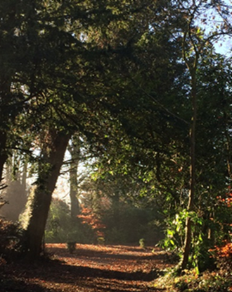
Leader:
In ainm an Athar agus an Mhic agus an
Spioraid Naoimh. Amen.

This morning we gather together and greet
each other, at the beginning of this new
school year, hopeful that we have left the worst of the Pandemic behind us.

We are grateful for the resilience, innovation, courage and patience our students, teachers, school staff, parents and administrators demonstrated over the past year. We begin this new school year in prayer because we are anxious for our students to resume school in person, yet still be safe from COVID-19.
We pray for a better year; for a safe return to classrooms; for the health of students, teachers and school staff; for school boards and administrators under pressure to make difficult decisions; and for parents exhausted by the uncertainty and constantly changing plans.
Help us, to bear with one another in love and patience as we face the new challenges this year will inevitably bring. We pray that our teachers banked enough summer renewal to face any new disruptions. We ask that the difficulties our students faced since the start of this pandemic will give them the confidence and courage to face whatever lies ahead. With confidence in God’s ability to do more than we ask or imagine, we pray that faith will deter fear and hope will bring new life.

Reader 1: A reading from the holy Gospel according to Matthew
(14: 22-33).
[Jesus] made his disciples get into the boat and go on ahead to the other side …
After sending the crowds away he went up into the hills by himself to pray. When evening came he was there alone, while the boat, by now, far out on the lake, was battling with a heavy sea, for there was a head wind.
In the fourth watch of the night he went towards them, walking on the lake, and when the disciples saw him walking on the lake they were terrified. ‘It is a ghost’, they said, and cried out in fear. But at once Jesus called out to them saying: ‘Courage, it is I. Do not be afraid’.
It was Peter who answered. ‘Lord’, he said, ‘if it is you, tell me to come to you across the water’. ‘Come’ said Jesus. Then Peter got out of the boat and started walking towards Jesus across the water, but as soon as he felt the force of the wind, he took fright and began to sink. ‘Lord, save me!’ he cried.
Jesus put out his hand at once and held him. ‘Man of little faith’ he said, ‘why did you doubt?’ and as they got into the boat the wind dropped. The men in the boat bowed down before him and said. ‘Truly, you are the Son of God’.
The Word of the Lord.
Pause for a moment of silence.

Reader 2:
Lord, as we begin this new school year, we thank you for bringing us safely here today, and pray that, in the storms which may be ahead of us, we will know you are with us always.
We pray to the Lord R. Lord hear our prayer.

Jesus’ drew strength from taking time to be alone and to pray.
Let us remember, as we return to the ‘busyness’ of school life, that it is good for us, too, to make time for stillness in our lives.
We pray to the Lord, R. Lord hear our prayer.

We pray for our students, for our whole school community, and for the success of the teaching, learning and all the other activities which will take place in our school this year.
We pray to the Lord, R. Lord hear our prayer.

We think of our Leaving Cert students still awaiting ‘results’. Bless them and guide them through this time of uncertainty.
We pray to the Lord, R. Lord hear our prayer.

We remember all those who have died during this pandemic. May they rest in peace.
We pray to the Lord, R. Lord hear our prayer.
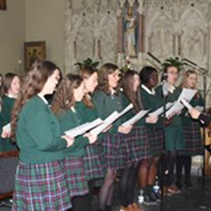

Leader: We pray together: Ár nAthair …

And together we will say the Kandle Coronavirus Prayer:
Loving and healing God,
we, the people of Kildare & Leighlin turn to you in prayer,
confident that you are with us and with all people in every moment.
We stand before you as people of hope, trusting in your care and protection.
May your faithful love support us and soothe the anxiety of our hearts.

Generous God,
fill us with compassion and concern for others, young and old,
that we may look after one another in these challenging days.
Bring healing to those who are sick with the virus and be with their families.
May those who have died rest in your eternal embrace.
Comfort their family and friends.
Strengthen and protect all medical professionals caring for the sick
and all who work in our medical facilities.
Give wisdom to leaders in healthcare and governance
that they may make the right decisions for the well-being of people.
We pray in gratitude for all those in our country who will continue to work in the days ahead in so many fields of life for the sake of us all.
Bless them and keep them safe.

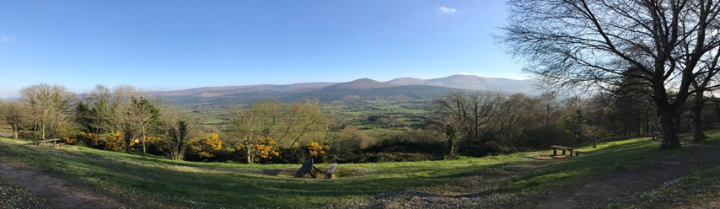
O God of creation and life,
we place ourselves in your protection.
May the mantle of your peace enfold us this day and tomorrow.
St Brigid, pray for us.
St Conleth, pray for us.
St Lazerian, pray for us.
May all the saints of God, pray for us. Amen.

Diocese of Kildare & Leighlin 2021

