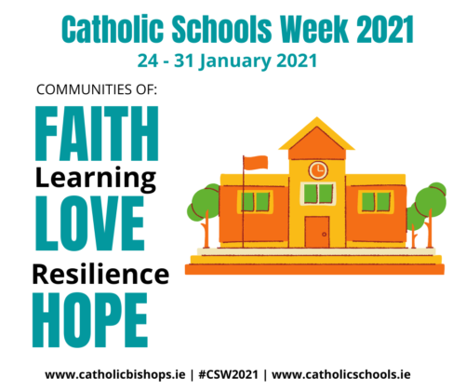
Gracious God

We ask that you send your spirit upon our Catholic School/s
Help all of us, to be,
as charitable as St. Brigid,
as prophetic as St. Conleth,
and as prayerful as St. Laserian.

May we use our gifts to help each other.
May everyone in our schools be living witnesses
of your love and care for the world

May our school communities be the places of
faith hope and love that you call us to be. Amen

