Staff Prayer for the Beginning of the new School Year – August 2020

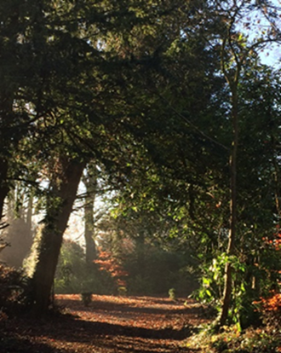
Leader:
In ainm an Athar agus an Mhic agus an
Spioraid Naoimh. Amen.

This morning we gather together and greet
each other, at the beginning of this new
school year, during the strangest of times.

On March 12th we left school presuming
we would be returning to normal after a
couple of weeks; thinking that maybe this
might stretch into the Easter holidays … and here we are this morning – five months later; and nothing is ‘normal’.

We have been through a testing time of isolation and of fear of this new virus which, with its ability to spread exponentially, has transformed our world and our lives in ways we could never have imagined six months ago.
We return today to a new order in schools; it will take some time to acclimatise.
Let us pray for each other this morning, for our students and the whole school community as we as we begin this school year, venturing into the unknown.
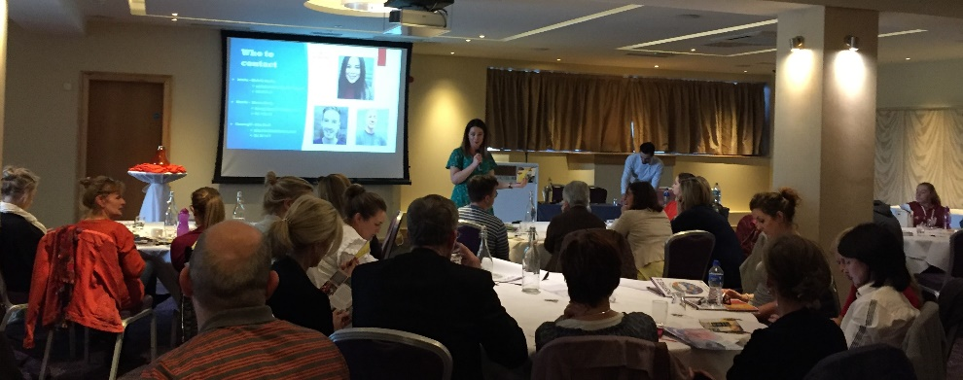

Reader 1: A reading from the holy Gospel according to Matthew
(14: 22-33).
[Jesus] made his disciples get into the boat and go on ahead to the other side …
After sending the crowds away he went up into the hills by himself to pray. When evening came he was there alone, while the boat, by now, far out on the lake, was battling with a heavy sea, for there was a head wind.
In the fourth watch of the night he went towards them, walking on the lake, and when the disciples saw him walking on the lake they were terrified. ‘It is a ghost’, they said, and cried out in fear. But at once Jesus called out to them saying: ‘Courage, it is I. Do not be afraid’.
It was Peter who answered. ‘Lord’, he said, ‘if it is you, tell me to come to you across the water’. ‘Come’ said Jesus. Then Peter got out of the boat and started walking towards Jesus across the water, but as soon as he felt the force of the wind, he took fright and began to sink. ‘Lord, save me!’ he cried.
Jesus put out his hand at once and held him. ‘Man of little faith’ he said, ‘why did you doubt?’ and as they got into the boat the wind dropped. The men in the boat bowed down before him and said. ‘Truly, you are the Son of God’.
The Word of the Lord.
Pause for a moment of silence.

Reader 2: A reflection from Sacred Space.

The Coronavirus has come as a huge shock to us, and within a very short time, it has challenged our attitudes and behaviours radically … In one sense, life continues as normal – and yet it’s not normal at all.
We are in a state of shock. In many ways, we have come to believe that we are in control of our lives, that we have a cure for every disease, that we can fend off all the dangers that threaten our securities. We have built up solid walls to protect us against every unwanted guest, but now our walls have been breached, and the unwanted guest is here. Our securities no longer seem so secure, something in our world is out of our control, and many don’t know where to turn.
Ultimately, our trust has to be in something more solid than we can ever find here on earth. Ultimately, God alone is our security. ‘God is our refuge and our strength, a helper close at hand in times of distress’ (Ps.46:1). Trust Him.

Reader 3:
Lord, as we begin this new school year, we thank you for bringing us safely here today, and pray that, in the storms which may be ahead of us, we will know you are with us always.
We pray to the Lord R. Lord hear our prayer.

Jesus’ drew strength from taking time to be alone and to pray.
Let us remember, as we return to the ‘busyness’ of school life, that it is good for us, too, to make time for stillness in our lives.
We pray to the Lord, R. Lord hear our prayer.

We pray for our students, for our whole school community, and for the success of the teaching, learning and all the other activities which will take place in our school this year.
We pray to the Lord, R. Lord hear our prayer.

We think of our Leaving Cert students still awaiting ‘results’. Bless them and guide them through this time of uncertainty.
We pray to the Lord, R. Lord hear our prayer.

We remember all those who have died during this pandemic. May they rest in peace.
We pray to the Lord, R. Lord hear our prayer.
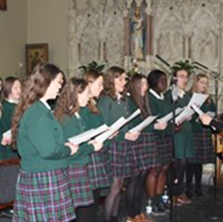

Leader: We pray together: Ár nAthair …

And together we will say the Kandle Coronavirus Prayer:
Loving and healing God,
we, the people of Kildare & Leighlin turn to you in prayer,
confident that you are with us and with all people in every moment.
We stand before you as people of hope, trusting in your care and protection.
May your faithful love support us and soothe the anxiety of our hearts.

Generous God,
fill us with compassion and concern for others, young and old,
that we may look after one another in these challenging days.
Bring healing to those who are sick with the virus and be with their families.
May those who have died rest in your eternal embrace.
Comfort their family and friends.
Strengthen and protect all medical professionals caring for the sick
and all who work in our medical facilities.
Give wisdom to leaders in healthcare and governance
that they may make the right decisions for the well-being of people.
We pray in gratitude for all those in our country who will continue to work in the days ahead in so many fields of life for the sake of us all.
Bless them and keep them safe.

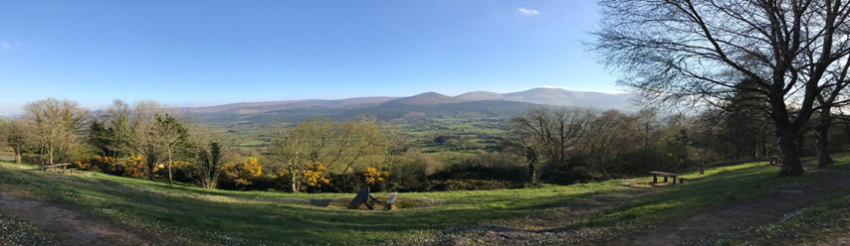
O God of creation and life,
we place ourselves in your protection.
May the mantle of your peace enfold us this day and tomorrow.
St Brigid, pray for us.
St Conleth, pray for us.
St Lazerian, pray for us.
May all the saints of God, pray for us. Amen.

Diocese of Kildare & Leighlin 2020

