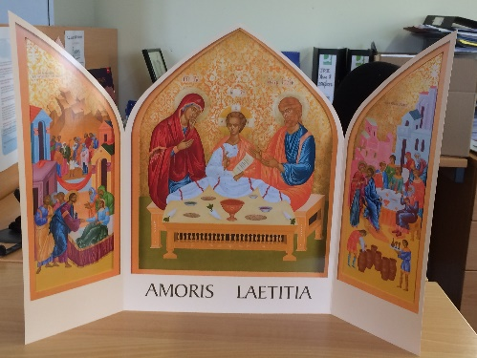
Prayer for Staff for the New School Year
2018-2019

Leader: As we begin our new school year let us take a few moments of quiet reflection. (Pause)

We thank God for the beautiful summer we have enjoyed this year, and for the opportunity we have had to renew our energy and revitalize our spirit.

We are mindful at this time of the celebration in Dublin of the World Meeting of Families, and of the visit of Pope Francis to Ireland.

Let us pray for each other and for all the students we will meet and teach this coming year, remembering that as teachers we belong, not only to our own families, but also to a wider family - that our school is a family of families, that we are called to inspire our students with a love of learning and a passion for social justice; that we are called to be role models for them.

Reader 1:
St. Paul tells us to:
“Show yourself, in all respects, a model of good deeds, and in your teaching show integrity”. Titus 2:7

R 2: We ask God’s blessing on each of us here as we begin this new school year.

R.3: We pray for new colleagues among us that they will experience in our welcome the joy and care for each other that we share in this school.

R 4: May our students be blessed with the ability to grasp every opportunity, both academic and extra-curricular, to develop themselves as rounded human beings and to strive to achieve their full potential.

R 5: We pray for parents that they will support and encourage their children in their education.

R.6: We ask that our whole school community, our family of families, will continue to be inspired by the Gospel, to work towards a world in which there will be equality, peace and justice for all.

Leader: We pray together::

God, our Father, we are brothers and sisters in Jesus your Son,
One family, in the Spirit of your love.
Bless us with the joy of love. Make us patient and kind,
gentle and generous, welcoming to those in need.
Help us to live your forgiveness and peace.

Protect all families with your loving care, especially those for whom we now pray:
[We pause and remember family members and others by name].

Increase our faith, strengthen our hope, keep us safe in your love,
Make us always grateful for the gift of life that we share.
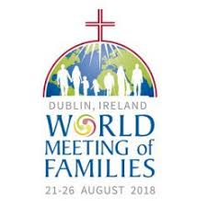
This we ask, through Christ our Lord, AMEN.

Mary, mother and guide, pray for us.
Saint Joseph, father and protector, pray for us.
Saints Joachim and Anne, pray for us.
Saints Louis and Zélie Martin, pray for us.

World Meeting of Families Prayer

KandLe.ie 2018

