St. Patrick’s Breastplate

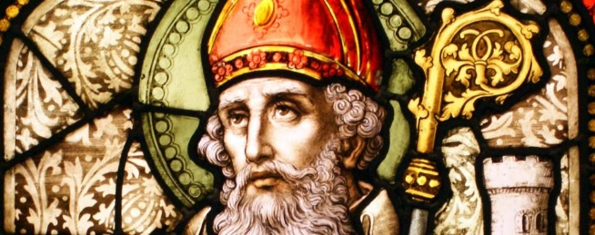
I arise today through the strength of heaven
Light of sun, radiance of moon
Splendor of fire, speed of lightning
Swiftness of wind, depth of the sea
Stability of earth, firmness of rock

I arise today through God's strength to pilot me
God's eye to look before me
God's wisdom to guide me
God's way to lie before me
God's shield to protect me

From all who shall wish me ill
Afar and a-near
Alone and in a multitude
Against every cruel, merciless power
That may oppose my body and soul

Christ with me, Christ before me
Christ behind me, Christ in me
Christ beneath me, Christ above me
Christ on my right, Christ on my left
Christ when I lie down, Christ when I sit down
Christ when I arise, Christ to shield me

Christ in the heart of everyone who thinks of me
Christ in the mouth of everyone who speaks of me

I arise today

