ST. BLAISE - Feast Day: February 3rd.

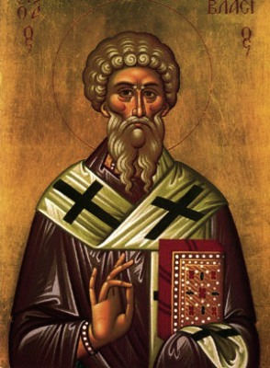
Patron of Throat Illnesses

February 3rd is the Feastday of St Blaise, the patron saint of throat illnesses.

The tradition of the blessing of the throats is credited to him. Two candles are blessed, held slightly open, and pressed against the throat as the blessing is said. Saint Blaise's protection of those with throat troubles apparently comes from a legend that a boy was brought to him who had a fishbone stuck in his throat. The boy was about to die when Saint Blaise healed him.

Very few facts are known about Saint Blaise. The legend of his life that sprang up in the eighth century tells us that he was born into a rich and noble family who raised him as a Christian. He became bishop of Sebastea in Armenia and was martyred under the reign of Licinius in the early fourth century.

Devotion to St. Blaise has been popular throughout the ages. Much of what is known of his life is based on legends. However, historical proof exists that Blaise was martyred for the Faith in his diocese of Sebastea in Armenia in the year 316.

The legends surrounding Blaise state that during the persecution of Licinius Blaise was forced into exile into the hills in the backcountry of his diocese. He lived as a hermit, spending his days in prayer and penance.
The legends say that one of the products of Blaise's holiness was that even the most wild of animals became his companions without causing any harm to him. One day hunters discovered Blaise while seeking wild animals for the amphitheatre and arrested him as a Christian. Blaise was taken to prison. He was tortured with an iron comb (an instrument designed for combing wool but was used here for shredding the skin) and finally beheaded.

St. Blaise is the Patron Saint of people with sore throats and of wild animals.
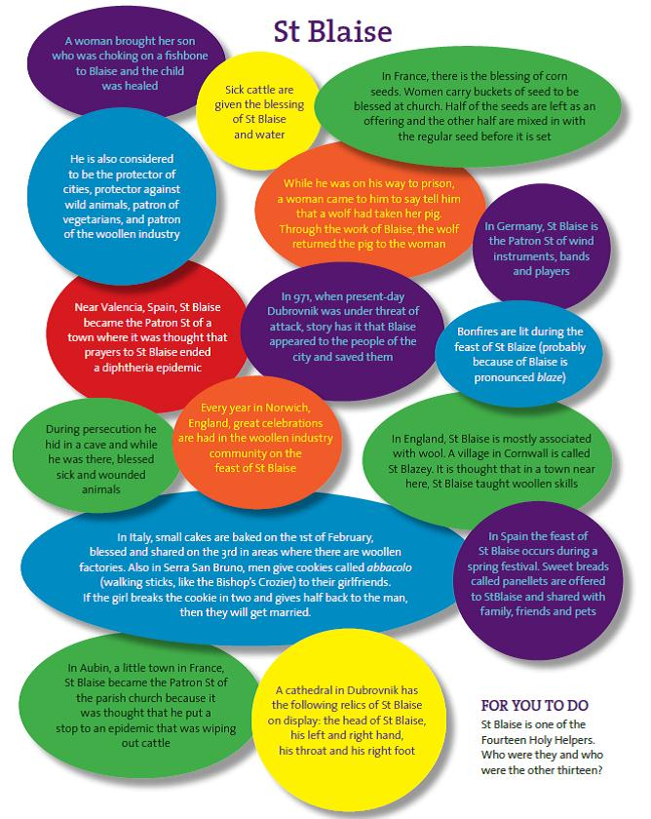
Prayer to Saint Blaise

May, Almighty God, through the prayers of St. Blaise, Bishop and Martyr, bless us and protect us from sickness of the throat.

Amen.

