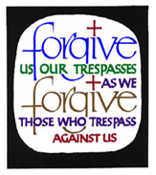
Lenten Reconciliation Service

Opening Hymn …

Priest: Sign of the Cross …
In the name of the Father, and of the Son and of the Holy Spirit. Amen. (Words of welcome)

As we begin this prayer we thank you, Father, for all the blessings you give us each day; we thank you especially for this time of quiet reflection and renewal.
You are a God of compassion and love; our merciful Father. We turn to you today to ask your forgiveness for all those times we fail to live as you would want to. Heal us, give us your grace, and help us always to bring your love into our homes, our school community and into the world in which we live. We ask this through Christ our Lord. Amen

Confiteor: The priest invites those present to pray together

I Confess to almighty God, and to you, my brothers and sisters,
that I have greatly sinned, in my thoughts and in my words,
in what I have done, and in what I have failed to do;
through my fault, through my fault, through my most grievous fault;
Therefore I ask blessed Mary ever-Virgin, all the Angels and Saints,
and you, my brothers and sisters, to pray for me to the Lord our God.

Scripture Reading Isaiah 40: 28-31

Do you not know? Have you not heard? The LORD is the everlasting God, the Creator of the ends of the earth. He will not grow tired or weary, and his understanding no one can fathom.
He gives strength to the weary and strengthens the weak.
Even young people grow tired and weary; they stumble and fall;
but those who hope in the LORD will renew their strength. They will soar on wings like eagles; they will run and not grow weary, they will walk and not be faint.

Psalm 51: (Recite alternate stanzas)
Have mercy on me, God, in your kindness. In your compassion blot out my offence. O wash me more and more from my guilt and cleanse me from my sin.
My offences truly I know them; my sin is always before me. Against you, you alone, have I sinned; what is evil in your sight I have done.
Indeed you love truth in the heart; then in the secret of my heart teach me wisdom. a purify me, then I shall be clean; O wash me, I shall be whiter than snow.
Make me hear rejoicing and gladness, that the bones you have crushed may revive. From my sins turn away your face and blot out all my guilt.
A pure heart create for me, O God, put a steadfast spirit within me.
Do not cast me away from your presence, nor deprive me of your holy spirit.

Give me again the joy of your help; with a spirit of fervor sustain me, that I may teach transgressors your ways and sinners may return to you.
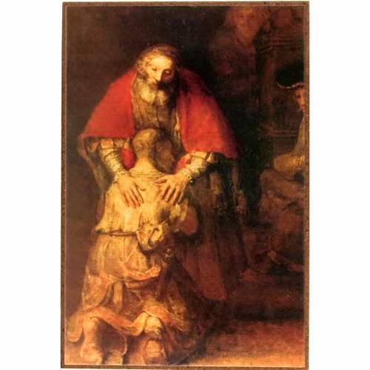
O rescue me, God, my helper, and my tongue shall ring out your goodness. O Lord, open my lips and my mouth shall declare your praise.
Gospel Reading (Priest) Luke 15: 11-32

Jesus continued: “There was a man who had two sons. The younger one said to his father, ‘Father, give me my share of the estate.’ So he divided his property between them.
“Not long after that, the younger son got together all he had, set off for a distant country and there squandered his wealth in wild living. After he had spent everything, there was a severe famine in that whole country, and he began to be in need. So he went and hired himself out to a citizen of that country, who sent him to his fields to feed pigs. He longed to fill his stomach with the pods that the pigs were eating, but no one gave him anything.
“When he came to his senses, he said, ‘How many of my father’s hired servants have food to spare, and here I am starving to death! I will set out and go back to my father and say to him: Father, I have sinned against heaven and against you. I am no longer worthy to be called your son; make me like one of your hired servants.’ So he got up and went to his father.
“But while he was still a long way off, his father saw him and was filled with compassion for him; he ran to his son, threw his arms around him and kissed him.
“The son said to him, ‘Father, I have sinned against heaven and against you. I am no longer worthy to be called your son.’
“But the father said to his servants, ‘Quick! Bring the best robe and put it on him. Put a ring on his finger and sandals on his feet. Bring the fattened calf and kill it. Let’s have a feast and celebrate. For this son of mine was dead and is alive again; he was lost and is found.’ So they began to celebrate.
“Meanwhile, the older son was in the field. When he came near the house, he heard music and dancing. So he called one of the servants and asked him what was going on. ‘Your brother has come,’ he replied, ‘and your father has killed the fattened calf because he has him back safe and sound.’
“The older brother became angry and refused to go in. So his father went out and pleaded with him. But he answered his father, ‘Look! All these years I’ve been slaving for you and never disobeyed your orders. Yet you never gave me even a young goat so I could celebrate with my friends. But when this son of yours who has squandered your property with prostitutes comes home, you kill the fattened calf for him!’
“‘My son,’ the father said, ‘you are always with me, and everything I have is yours. ³² But we had to celebrate and be glad, because this brother of yours was dead and is alive again; he was lost and is found.’”

(Priest:) Short few words of introduction to the examination of conscience)

Examination of Conscience Readers A and B
(Read slowly & reflectively, pause for a few moments silence between each reflection)

RA Lord, we ask today that our hearts may never be hearts of stone; that we may always remember that you are a God of compassion who says to each one of us “let’s talk this over”; and so, we examine our lives in the light of the Ten Commandments.
(Pause):
I am the Lord your God, you shall not have strange God’s before me.

RB Is God at the centre of my life? Have I treated people events or things as if
they are more important than God?

RA You shall not take the name of the Lord your God in vain

RB Is my language careless? Have my words put down God, the Church or other people? .

RA Remember to keep holy the Lord’s Day

RB Do I go to Mass on Sundays and Holy Days of Obligation? Do I look for ways to spend time with family, or to relax on a Sunday?

RA Honour your father and your mother.

RB Do I show my parents respect? Do I try to have good communication with them? Do I criticize them when they don’t see things my way?

RA You shall not kill.

RB Have I harmed anyone through physical, verbal or emotional means, through gossip or social media? When I hurt others
do I realise that I am killing something inside them?

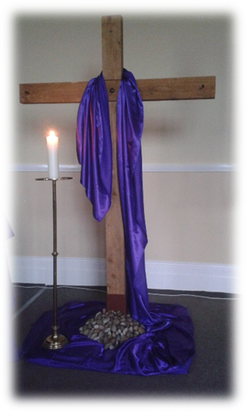
RA You shall not commit adultery.

RB Have I respected the physical and sexual dignity of others and of myself?

RA You shall not steal.

RB Have I taken something belonging to another person? Have I added to the environmental damage of the earth to the cost of future generations?

RA You shall not bear false witness against your neighbour.

RB. Have I gossiped, told lies or embellished stories at the expense of another?

RA You shall not covet your neighbour’s spouse.

RB Have I disrespected or been jealous of other people’s relationships?

RA You shall not covet your neighbour’s goods

RB Am I content with all that I have, or do I compare myself to others and want the things they have when I don’t need them?

Individual confession …
During this time reflective music may be played eg Taize music or, the official Jubilee hymn etc.

Our Father …

Priest: Gracious God, we thank you for the love you shower upon us, and for the gift of your forgiveness. Give us the grace to really appreciate your mercy in our lives; let your Holy Spirit transform our hearts that in our lives we may always be
merciful to others.
We ask this through Christ our Lord. AMEN.

Final Blessing.
The Lord be with you. And with your spirit.
May almighty God bless you in the name of the Father and of the Son and of the Holy Spirit.
Go in peace and be merciful always, just as your heavenly Father is merciful.

Closing Hymn …

