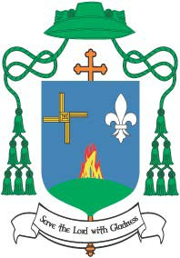

When a Loved One Dies …

A Pastoral Letter from Bishop Denis Nulty

to the Parishioners of the Diocese of Kildare and Leighlin

Dear Friends,

THE CONSOLATION OF OUR FAITH
The death of a loved one, even when it is expected, always brings with it the great sadness of parting. Families are so often left with a tremendous sense of shock and loss as well as deep feelings of personal grief. Into this grief the Church carries, through its prayers and actions, the consolation and comfort of its faith. The Church reaches out to all those who grieve with a message of hope. For we believe in the resurrection and, therefore, we believe that death is not the end. So while the pain of mourning cannot be taken away, our faith enables us to pray in a spirit of hope for a loved one who is returning to God and to life everlasting.

REMEMBERING OUR DEAD IN NOVEMBER
I write to you in the month of November, a time when traditionally we remember and pray for our dead. I am particularly mindful of those of you who have lost a loved one in the past year and I hold you in my prayers. Know that your parish community also prays for you.
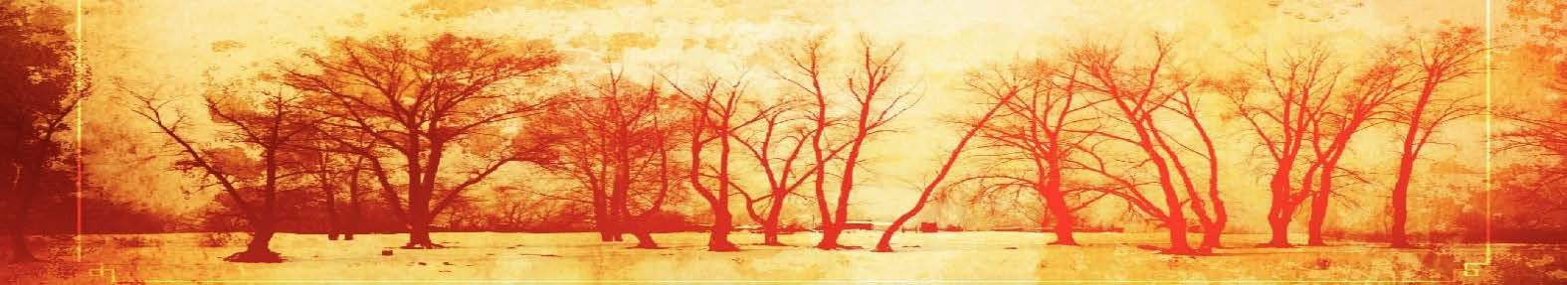

HOW WE MARK THE DEATH OF A LOVED ONE
As we move further into the winter of the year it is a good time to look to how we, as members of the Christian community, mark the passing of a loved one through the prayers and actions of the funeral rites. Many of you will be aware that for the last two years, we have had on-going discussions within the diocese about the celebration of funerals in our parishes. Alongside an extensive parish survey, on a number of occasions I have met with funeral directors, parish staff, clergy, funeral ministry teams, those recently bereaved as well as many parish volunteers. Together we have explored how best to celebrate the funeral rites, our acts of public worship, in the circumstances of people’s lives today. I have listened very closely to what people have said and am very grateful to all who shared in these conversations and for the insights they brought to our exploration.

In this moment of sorrow, the Lord is in our midst and consoles us with his word.
Blessed are the sorrowful they shall be comforted.
(Taken from the Order of Christian Funerals)

PUTTING PRAYER INTO PEOPLE’S HANDS
One immediate response to these conversations was the creation and distribution of three prayer cards for use in the home and funeral home to help support families. These were issued in the Spring and have been very warmly received.

FUNERALS CELEBRATED WELL BRING THE SOOTHING BALM OF CHRIST
In Ireland we have a long tradition of celebrating funerals well, and the diocese of Kildare and Leighlin is no exception to this. In order to support and encourage the continued worthy and dignified celebration of funerals into the future, my next step as bishop is to address particular funeral practices. During the diocesan wide consultation process, people asked time and again for clarity in regard to these practices. I am happy to offer such clarity in this letter. In doing so I am keenly aware of the sensitive ministry that happens every day in parishes as families prepare to celebrate the funeral of a loved one. It is in this pastoral ministry that the clarity I outline will be exercised. I firmly believe that the funeral rites of the Church, celebrated well in the local community, bring the soothing balm of Christ’s comfort and hope at a time of devastating loss.

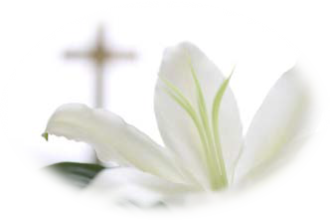THREE AREAS IN PARTICULAR emerged over the past two years of conversations, as follows:

Words of Remembrance

The eulogy does not form any part of the official funeral rites of the Church.
In recent years a practice has emerged of a family member speaking publicly in remembrance of the deceased at some stage during the funeral rites. I want families to be aware that this is something that no family should ever feel they have to do. If a family, however, wishes to share words of remembrance, it will be helpful for them to be sensitive to the appropriateness or otherwise of what is said in a public and prayer context.

If a family chooses to share words of remembrance the following practices are expected:
- Only one person, a relative or friend of the deceased, speaks on behalf of the family. This may often be too difficult for an immediate family member who is overcome with grief or who may not be used to speaking in public.
- The words to be said are scripted, agreed by the priest celebrant and last no longer than three minutes.
- The content of the sharing focuses on words of appreciation of the person who has died and of their faith, and might also include thanks for support around the death.

The appropriate time for these Words of Remembrance are:
- At the Reception of the Body, if it takes place the evening before the Funeral Mass.
- At the graveside or Crematorium.
- At the Funeral Mass before the Prayers of Commendation and Farewell.

Lord God, you are attentive to the voice of our pleading. Let us find in your Son comfort in our sadness, certainty in our doubt, and courage to live through this hour.
Make our faith strong through Christ our Lord. Amen. (From the Order of Christian Funerals)

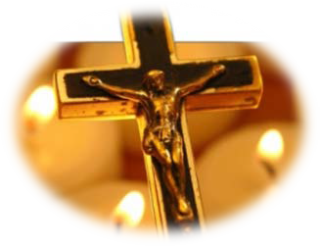

Presentation of Personal Mementoes

Across our parishes there is a new and growing custom of personal symbols or mementoes also being presented. These mementoes reveal aspects of the life of the deceased, their life, work, interests, faith, etc. They are different to the Christian symbols placed on the coffin and to the gifts of bread and wine that are presented during the Mass for transformation into the Body and Blood of Christ.

Because this is not part of the official rites of the Church, a family should not feel that mementoes have to be presented. However, if a family wish to do so, the following practices are expected:
- The mementoes are placed on a suitably prepared table of remembrance located near the coffin or within the sanctuary, rather than on the coffin or on the altar.
- The chosen mementoes are appropriate and respectful to the church setting.
- The mementoes are presented at the beginning of the Mass or Reception of the Body, and not at the preparation of the altar.

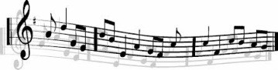The Choice of Music
Music is a central element of Catholic worship. We give thanks and praise to God through our music and it reveals truths of our faith. Instrumental music can express both our human emotions before God and God’s healing presence to us in a way that no other medium can. The music we sing in our acts of worship support our prayer in that very moment. Because of this, music selections need always to serve and enhance that prayer and not lead us away from worship of God.

Sometimes families will ask for a favourite song of the deceased to be included during the Funeral. It has happened on occasion that the lyrics to a song has been opposite to our beliefs or inappropriate to Christian worship. To assist families in making their choices of music I am asking for the following:
- That families agree all music choices with the priest celebrant ahead of time. The family can do this directly with the priest or they can ask the person leading the music, a member of the parish staff or a member of the funeral ministry team where one exists, to check and agree the music with the priest.
- That if a secular song is agreed that it be sung during the sympathising at the evening removal, as the coffin leaves the church, at the conclusion of the prayer at the crematorium or at the graveside.

A WORD ABOUT CREMATION
The practice of cremation of the body is still relatively small within our diocese but the likelihood is that it will increase. In anticipation of this, I want to share the following comments:
- As stated in the recent Instruction from Rome, cremation is a valid and acceptable practice in the Catholic Church, provided it is not being chosen for reasons in opposition to our faith.
- When cremation is chosen, it will as a general rule take place after the funeral Mass. The cremated remains are shown the same respect as the body of a Christian; the vessel they are contained in, as well as how this vessel is treated, demonstrates respect and reverence for the sacredness of this person whom we now commend to the care of God.

  - Just as the body of Jesus was buried, with his followers going to great lengths to do so, the Church desires that the cremated remains of a Christian either be buried or entombed at the earliest opportunity, for example around the time of the Month’s Mind. The Church provides a prayer ritual for the burial or entombment of ashes. Having a designated place of burial or entombment gives the deceased a place in which to be memorialised as well as giving a place of focus for family and friends, and the Church to remember and pray for the deceased.

As a diocese we will continue to work with funeral directors and crematoriums to support families who choose cremation for their loved one.

DEVELOPING PARISH FUNERAL MINISTRY
A small number of parishes already have a group of trained lay people who serve as part of a funeral ministry team. These people work with the parish clergy in assisting families to prepare and celebrate the funeral rites. This might include leading prayer in the home / funeral home, helping families in preparing for the Funeral Mass and/or leading prayers in the crematorium.
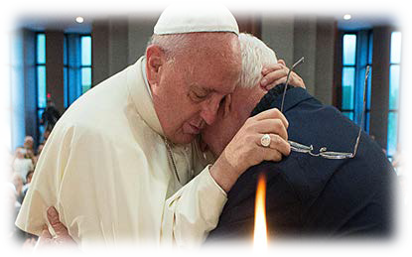I am delighted that training for new parish funeral ministry teams is currently underway with half a dozen parishes participating in this particular round of formation. In the coming years these volunteers will play an essential role in continuing the rich tradition of the Church’s ministry to the bereaved.

‘If one member suffers in the body of Christ which is the Church, all the members suffer with that member’ (I Corinthians 12:26) ...when a member of Christ’s Body dies, the faithful are called to a ministry of consolation of those who have suffered the loss of one whom they love. (From the Order of Christian Funerals)
FINAL THOUGHTS
In recent weeks I just finished reading the late Fr. Michael Paul Gallagher’s book ‘Into Extra Time’. It was a very moving testament by a man of deep faith who faced his own challenges as death beckoned. My prayer is that this pastoral letter will encourage those who are accompanying loved ones nearing death. My hope is that this pastoral will bring consistency and clarity to our practice around funerals. My aim is that this pastoral will become a resource reference for that most tender moment, when we are planning the funeral of someone we love. I thank the many people in Kildare & Leighlin who have engaged in this conversation over the past two years and I trust that those gatherings and meetings have found some expression in this pastoral letter. In the words of the Eucharistic Prayer, I pray: “Remember, also our brothers and sisters
who have fallen asleep in the hope of the resurrection, and all who have died in your mercy:
welcome them into the light of your face.” (Eucharistic Prayer II)

Remembering all our deceased loved ones in this month of November, Blessings and prayers,
Denis Nulty
Bishop of Kildare & Leighlin November 2016

