Reflection: Gone from my sight

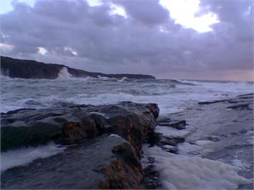

I am standing upon the seashore.
A ship at my side spreads her white sails to the morning breeze and starts for the blue ocean. She is an object of beauty and strength. I stand and watch her until at length she hangs like a speck of white cloud just where the sea and sky come to mingle with each other.
Then, someone at my side says; "There, she is gone!"
"Gone where?"
Gone from my sight.
That is all.
She is just as large in mast and hull and spar as she was when she left my side and she is just as able to bear her load of living freight to her destined port. Her diminished size is in me, not
in her.
And just at the moment when someone at my side says, "There, she is gone!"; there are other eyes watching her coming, and other voices ready to take up the glad shout;
"Here she comes!"
And that is dying.

God of the living and the dead, of the visible and the invisible, of the seen and the unseen; bless all, everywhere and in everytime. For no one and no thing is beyond your generous love. Amen.

* by Henry Van Dyke, a 19th Century clergyman, educator, poet, and religious writer.

