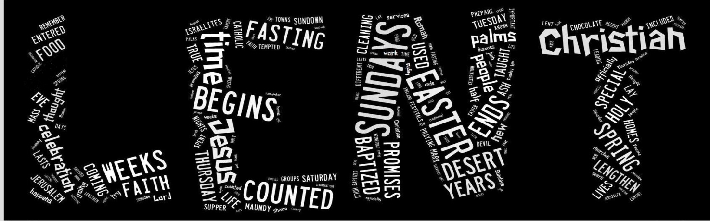
What is Lent?
The period of forty days (not counting Sundays) before Easter is known as Lent. This is the time of year in Ireland when the days begin to lengthen with the coming of spring.

The weeks of Lent were once the time when new Christians, who were to be baptized on Easter Eve, were taught about the Christian faith and life. Those who had already been baptized thought again about the promises they had once made and promise to be true to them. Lent was a time for spring-cleaning lives, as well as homes.

When does Lent begin?
Lent begins on Ash Wednesday, the day after Pancake Tuesday and six and a half weeks before Easter Sunday. The last week of Lent begins with Palm Sunday, which celebrates the day Jesus entered Jerusalem and the people lay down palms at his feet.

When does Lent end?
Lent lasts for 40 days and ends the day before Easter Sunday, which is known as Holy Saturday. Sundays are not counted in the 40 days.

In the Roman Catholic Church, Lent officially ends at sundown on Holy Thursday (Maundy Thursday), with the beginning of the mass of the Lord's Supper.

Why does Lent last for 40 days?
The 40 days mark the 40 years of the Israelites going through the desert and the traditional 40 days of Jesus fasting in the desert.

Why are Sundays not counted in the 40 days?
Sundays are always a day of celebration in the Christian church and so they cannot be included in the 40 days of Lent.

What happens during Lent?
During Lent Christians used to fast (give up food) but nowadays people try to give up something like chocolate. Lent is a time when Christians remember the 40 days and nights Jesus spent alone in the desert without food being tempted by the Devil. Jesus used this time to prepare for His work by fasting and praying.
There are many special days in Lent leading up to Easter, the most important of all Christian festivals.
Ashes

Lent
In old English “Lenten” meant Spring and as in March the days begin to lengthen the Saxons called it “lencten monath.” Usually most of the days of fasting between Ash Wednesday and Good Friday fall in March and so this period was given the name “Lencten Faesten”, or Lent.
In the earliest days of the Church there were only two or three days of fasting before Easter. It was not until around the fourth century that the longer period was introduced. At first, it was thirty six days but later became forty days to correspond with Christ’s fast in the wilderness.
The ashes we receive on our foreheads on Ash Wednesday are an annual reminder of the passage of time and our constant need of repentance, our need to change. The ashes were made from the burning of the palms which had been blessed last Palm Sunday. We had waved palms in praise of Christ at the beginning of Holy Week and now we have failed him many times since that day. Even in their origin therefore, the ashes show the passing of this world and all created things.

Centuries ago it was custom, at the beginning of Lent, to sprinkle ashes on public sinners as they came into the church in repentance. Now, we acknowledge publicly that we are all sinners and in need of repentance. Carrying the ashes on our forehead indicates our willingness to do repentance for our sins. The traditional words used as the ashes are placed provide a timely reflection: “Remember, you are dust and to dust you will return.” The alternative verse used in many churches focuses our attention on the deep meaning of our Lenten observance: “Turn away from sin and be faithful to the gospel.”

Lent is….

A time to struggle with our selfishness.
A time to struggle with our lack-lustre performance on many fronts,
a time to improve.
A time to struggle with insensitivity in our dealings with family, with teachers, with friends.
A time to struggle with attitudes that are negative.
A time to struggle against our compulsions – to eat too much, to waste time, to talk too much, to talk too little.
A time to struggle with the things that knock us off the path of friendship with God.
A time to struggle to be more of what we might be.
A time to struggle to lift our life-act onto a new level.
A time for new timetables and good resolutions.
Jesus struggled. An inner struggle, inner turmoil, inner distress.
The kind of struggle that drives people mad. Or the kind of struggle that makes saints.

Forty Days
What’s all this about forty days? Lent is from Ash Wednesday to Easter Sunday and that makes forty-six days. The answer is that we do not count Sundays in the forty days of Lent. You can enjoy the Sunday as the Lord’s Day to celebrate. Why not treat yourself to something as an encouragement to get on with Lent on Monday?
It was quite early in the history of the Church that the preparation for Easter took the form of forty days special prayer and penance. The number forty was in imitation of Christ who spent forty days in the desert. The Christians in the Eastern tradition needed seven weeks to complete their forty days because they excluded Saturday as well as Sunday from their days of penance. The Western tradition excluded Sunday only so six weeks provided thirty six days, nearly enough. Still four days more were needed to make up the forty. The solution was to start Lent three days before the first Sunday. They did this in the Seventh century and so today we have Ash Wednesday, forty days (and six Sundays) before Easter.

A Lenten Meditation
Theme: The Cross
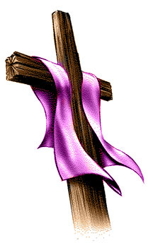
INTRODUCTION:
(With soft background music and a candle lighting the students make themselves comfortable and restful in a circle around a cross with a purple cloth draped across the two arms. Paper and pens by their side)
…. Close your eyes. Be aware of the touch of clothing on your back, or the pressure of your back against the chair… now be aware of your hands resting on the chair… your sitting position… Now feel your feet touching your shoes.
Move to being aware of your breathing. Become aware of the air as it comes in and goes out through your nostrils… Do not concentrate on the air as it enters your lungs. Limit your awareness to the air as it passes through your nostrils. Do not control you breathing.

MEDITATION
People have different crosses to carry in life – physical, emotional, social …. We carry our crosses carefully, trying to make sure they don’t take too much out of us. That Jesus could act out of love to the extent of dying on a cross is a mystery which is hard to imagine.
Come with me as in my imagination I draw my cross…
- I think of the hardships I see in my own family… the ones I try not to see, the struggles that make life difficult for my friends.
- I think of the journeys I find difficult to make… being kind to the people who hurt me, asking forgiveness from someone I have hurt, being truthful… are there others?
From all of this what does my cross look like… Is it harsh, dark, covered in thorns? Perhaps it is smooth and well-worn as I never leave it for too long without climbing onto it?
In your imagination draw your cross, the one made from the journey of your life.

ACTIVITY:
- Lower the music and invite students in their own time to open their eyes and come back to the room.
- The cloth is removed from one of the arms of the cross, symbolising our commitment to live as a loving person.
- Invite students to take up their paper, pens and in silence draw their own cross, the one imagined in their meditation.
- When each one has completed the task and placed their drawing around the cross, ask some to describe their drawing.

CONCLUSION:
We have a variety of crosses and we need one another and God’s help to carry them.
Lent is a time when we are reminded of God’s love for us especially when we are weighed down.

The purple cloth is fully removed from the cross as a symbol of the depth of God’s love for us. The empty cross reveals that death and resurrection are also possible for us.

We ask you loving God, to strengthen our character so that we might grow in our relationships with each other. Help us to be sincere and tolerant in our attitudes to others.
Amen

LENT PRAYER SPACE
WE CARRY OUR CROSSES
PREPARATION
In or near your prayer space hang a large drawing of a cross, beneath which these words are written: “We want to follow Jesus.” Have small slips of paper and pencils for each student as well as a piece of blu-tack or alternatively use Post-its. Place on your prayer table a Bible (open to Luke 23:44-47) and a votive candle.

OPENING PRAYER
Leader Glory and praise to you, Lord Jesus Christ. We greet you with love, and ask that you help us to listen carefully to your words.

All Please open wide our minds and hearts. Amen

Leader Lent is a six-week period when the whole church focuses on Jesus. During these weeks we are invited to think about things that he said and did. We move together toward Good Friday, and we move from these to Easter Sunday and beyond, where we experience Jesus as our risen Saviour.

Reader 1 During Lent, with our eyes on Jesus, we try to spend more time at prayer, more time talking to God and listening to God.

Reader 2 During Lent, with our eyes on Jesus, we try to be more aware of the needs of others, and to share our time and our money with the poor, the hungry, and the homeless.

Reader 3 During Lent, with our eyes on Jesus, we try to grow stronger as persons by learning to say no to our sins and our failings.

Leader With our eyes on Jesus, we journey through Lent trying to understand and accept what God has in store for us. Jesus did this, and he is our example. Even as he died, Jesus gave himself over to whatever God wanted of him. Let us listen now to a description of his death on the cross.

Reader 4 It was now about noon and darkness came over the whole land until three in the afternoon, for the sun stopped shining. Jesus, having been on the cross three hours, uttered a loud cry and said: “Father, into your hands I give over my spirit.” After he said this, he died.” The Word of the Lord.

GUIDED MEDITATION
Leader Close your eyes and slowly breathe in and out. Imagine that you are present at the crucifixion and that Jesus looks straight at you. What are your thoughts and feelings? (Pause) What do you want to say to him about your life right now? Talk to Jesus now in your own words about how you want to change and grow with his help. (Pause)
After a minute or so, have all open their eyes.

GROUP RESPONSE
Leader I will now distribute small slips of paper on which you can write a word or two to describe how you will try to become a better person this Lent.
Allow time for writing and then have students come forward one at a time to attach their papers to the cross. When all are attached, have two students hold up the cross for the closing prayer.

CLOSING PRAYER
Leader Jesus, please receive our good intentions. Help us to be true to them through all of Lent.
We adore you, O Christ, and we praise you. Amen.
A REFLECTION FOR LENT

Today I invite you to come in spirit to a courtyard.
It’s chilly. A warm charcoal fire is ablaze.
Let us get up to the fire and warm our hands.
A young man joins us. He is bearded, strong, commanding.
He too warms himself by the fire.
A young girl appears “you too were with Jesus”
She is composed, firm in her conviction.
The young man denies it “I do not even know the man.”
Peter the friend of Jesus, one of his faithful companions.
Peter who had sworn “I will never forsake you” now denies that he ever knew Jesus.
Why? … Fear.
Fear overcame Peter.
A young girl representing the super power of the day – the Roman Empire – instils a fear so great, that Peter denies Jesus.
Jesus arrested, is now in the hands of the ruling power.
Experience had taught that crucifixion was imminent.
So Peter slipped away and fled… in fear.
Not much had changed.
The oppressor and the oppressed.
Jesus in his day was on the side of the oppressed.
In reaching out in love he broke down the social barriers of his day.
He spoke to the Samaritan.
Jews and Samaritans did not mix.
He healed the leper.
Lepers were despised.
He healed on the Sabbath.
In doing so he was a threat to the ruling bodies of his day.
So they feared him.
They plotted his death.
Faithfulness to his call, led to his death.
Likewise with Martin Luther King, who spoke out for the cause of African Americans.

Archbishop Romero, who worked tirelessly for the poor and oppressed in El Salvador.
Gandhi who advocated peace in India.
The list goes on………
For each, the price was high – death.
Fear, at all levels.
Fear in the hearts of the oppressor.
Lest their power be taken from them by the power of those who advocate justice.
And fear in the hearts of the oppressed because if they speak out, they could be shot down, their life taken from them.
It is not easy to solve the problem of oppression, of greed.

“Make me a channel of your peace”
How?
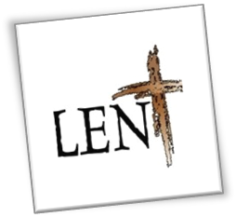
In our day-to-day living, let us not be oppressors.
Let us not instil fear
On our classrooms
In our homes
In our places of recreation
In our streets.
Let us be instruments of peace
Let us be instruments of love
for perfect love casts out all fear.
That is the ultimate call of God to each of us.

After the Resurrection, Christ appeared to Peter…
No recriminations…
Jesus simply calls Peter by name
“Peter, do you love me?”
And in reply he says “Feed my sheep”.
Christ calls you now by name
“______________”, do you love me?”
And in reply he says
Care for one another
Love one another.
Penitential Service during Lent
Entrance Hymn/Song

Sign of the Cross

Introduction
God loves us even when we sin and God is always waiting to forgive us.
No matter how many times we have failed,
No matter how serious we think our sin is,
God waits for us.
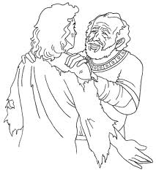
In the parable of the Prodigal Son, Jesus gives us a picture of God as someone who loves and forgives.
The Prodigal Son wasted every gift he had.
He made a mess of his life.
He turned back to his father only when he had nowhere else to go.
But, his father gives him an unbelievable welcome home.
He is already out searching for him, and when he sees him,
he runs to his son, hugs him
and throws a big party to celebrate his return.
He forgives his son and welcomes him home
Even before his son has a chance to open his mouth.

Gospel Reading – Luke 15: 11-32 (The Prodigal Son)

Leader
The way the loving father welcomed his son back home is the way God welcomes us in the Sacrament of Reconciliation.
All God asks is that we return and try again.
God does not hold the number of sins against us.
God just wants us to turn away from our sin, to say we are sorry and to try and change for the better.
In the Sacrament of Reconciliation, God forgives our sins and we make a new beginning.

Hymn/Song

Examination of Conscience
Do I respect God or Do I create Gods: e.g. money, power, ownership, success.
Do I respect God’s name or Do I misuse it: e.g. perjury in court, wishing evil on others.
Do I respect God’s time or Do I disregard it: e.g. refuse to listen, fail to build a
believing community, laziness, ungrateful.
Do I respect parents/authority or Do I cause pain: e.g. demanding, unhelpful, disrespectful,
fail to grow in responsibility.
Do I respect life or Do I diminish it: e.g. drinking, eating, use of addictive
substances.
Do I respect property or Do I damage it: e.g. school property, home property,
public property, environmental property.

Prayers of Repentance
Lord,
For the times we have failed to build our relationships with you and have chosen to be blind to your presence in Scripture, creation, community and ourselves.
Lord, we ask your forgiveness.
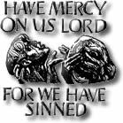
For the times we have failed to grow in family relationships by selfishness, lack of affection, broken promises and unforgiveness.
Lord, we ask your forgiveness.
For the times we have failed to build friendships and community through indifference, laziness, fear, jealousy or violence.
Lord, we ask your forgiveness.
For the times we have failed to grow in truth to ourselves.
Lord, we ask your forgiveness.
For the times we have caused damage to the environment and property.
Lord, we ask your forgiveness.

Conclusion
Before we finish... we look to the future realising that we are all slowly growing towards that person we will yet be. With that in mind, we might listen to the following piece of advice found in 1962 on a Baltimore tombstone.
Reader 1: Go placidly amid the noise and haste, and remember what peace there may be in silence. As far as possible, without surrender, be on good terms with all persons.
Speak your truth quietly and clearly; and listen to others, even to the dull and ignorant; they too have their story.
Reader 2: Avoid loud and aggressive persons; they are vexations to the spirit. If you compare yourself with others, you may become vain and bitter, for always there will be greater and lesser persons than yourself. Enjoy your achievements as well as your plans.
Reader 3: Keep interested in your own career, however humble; it is a real possession in the changing fortunes of time. Exercise caution in your business affairs, for the world is full of trickery. But let this not blind you to what virtue there is; many persons strive for high ideals, and everywhere life is full of heroism.
Reader 4: Be yourself. Especially do not feign affection. Neither be cynical about love; for in the face of all aridity and disenchantment it is as perennial as the grass. Take kindly the counsel of the years, gracefully surrendering the things of youth. Nurture strength of spirit to shield you in sudden misfortune. But do not distress yourself with dark imaginings. Many fears are born of fatigue and loneliness.

Reader 5: Beyond a wholesome discipline, be gentle with yourself. You are a child of the universe no less than the trees and the stars; you have a right to be here. And whether or not it is clear to you, no doubt the universe is unfolding as it should.
Reader 6: Therefore be at peace with God, whatever you conceive Him to be. And whatever your labours and aspirations, in the noisy confusion of life, keep peace with your soul. With all its sham, drudgery and broken dreams, it is still a beautiful world. Be cheerful. Strive to be happy.
Final Prayer
Let us bow our heads and ask for God’s blessing.
Let us go forth to spread God’s peace and mercy.
We make our prayer though Christ, our Lord. Amen.

