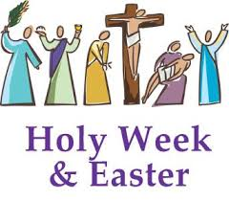

Reflection for Holy Week and Easter

During this strange time of the Corona Virus, Covid 19, when we are all in some form of isolation, parted from family, unable to work, distancing ourselves from others, it is perhaps a good time to remember that Lent reminds us of the time that Jesus spent in the desert. A time he spent preparing for his work by fasting and praying. We may be facing more than forty days of this current situation, but as Christians, it is the hope that we have been given through the resurrection of Jesus that sustains us when times are difficult.

As we all experience our own deserts this Lent let us remember that just as the seasons reflect the paschal mystery, we too will experience life and light at the end of this tunnel. Nature itself is already showing us how a time of rest – of ‘cocooning’ to use that now infamous phrase – of slowing down the chaotic, unrelenting busyness that has become the reality of our daily lives, can lead to a whole resurgence of health and new life for our planet.

While we all look forward to that time of new life – of getting back to being out, about and meeting others, let us pray that we may be able to retain something of our slowdown.

Let us use these final days of Lent, these days of enforced isolation, to revive our inner selves, to renew our relationship with God, to prepare well for Easter and to be grateful for the extraordinary hope we have inherited as Christians through the power of the Resurrection.

“Be still and know that I am God”
Psalm 46:10

**************************

