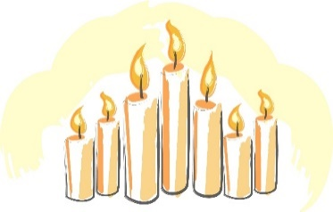
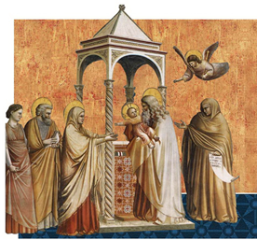
The Presentation of Jesus in the Temple
Candlemas Day February 2nd.

The Church celebrates the Feast of the Presentation of Jesus in the Temple on February 2.

As was the Jewish custom at the time, and in accordance with the Mosaic Law, forty days after Jesus was born, Joseph and Mary brought him, to the Temple in Jerusalem, to dedicate, or offer, him to God. It was customary to also bring a gift of doves or pigeons.

They were greeted there by an old man named Simeon to whom God had revealed that he would see the Messiah before he died. Simeon took the baby into his arms and praised God saying that now he had seen this child he could die in peace.
“At last, all powerful Master, you give leave to your servant to go
in peace, according to your promise”. (Luke2:29)

At that time, living in the Temple, there was also an elderly widow named Anna who served God by praying and fasting. She was known as a prophetess. When she saw the Child in Simeon’s arms she too recognized him as the promised Messiah.
Today we celebrate the fact that Simeon and Anna recognized Jesus as the Light of the World.
“For my eyes have seen your salvation which you have prepared
for all nations, the light to enlighten the Gentiles and give glory to
Israel, your people”. ( Luke 2: 30-32)

While today’s feast is known as the Feast of the Presentation of Our Lord, it was historically called “Candlemas” because of Simeon’s prophecy of Jesus being a light for the Gentiles.
Today’s liturgy includes the blessing and procession of candles and many people bring candles to their local church, where they are blessed and used for the rest of the year; the blessed candles are seen as a symbol of Jesus, the Light of the World . Before the advent of electricity this was hugely symbolic as candles would have been essential to bring light to people’s homes.

Today we pray that, like Simeon and Anna, we may live with a sense of the presence of God in our lives, trying each day to be still and to listen and respond to whatever it is that God may be asking of us. Like them too, may we develop a real sense of gratitude, remembering to praise and thank God for all the gifts we receive each day.
Lord, may we each live our lives in the Light of Christ, deepening our faith and bearing witness in all that we do to the joy of the Gospel.

See: Luke Chapter 2:22-40.

Additional note:

We are all familiar with the ‘Twelve Days of Christmas’ which follow Christmas Day on 25th December and end on January 6th, the feast of the Epiphany.

In the Western Church the first Sunday after the Epiphany, the Feast of the Baptism of the Lord is seen as marking the actual end of the Christmas season. After this Ordinary Time begins.

However, for centuries it was the feast of the Presentation of the Lord which marked the end of the Christmas season and Christmas decorations, particularly the Crib, would be kept up until February 2nd.

The Christmas season was celebrated for forty days, matching the forty days of penance which would shortly follow during the season of Lent.
------------------------------------------

