This Tonight is the Meeting Place

This tonight
Is the meeting place
Of heaven and earth.

For this tonight
Is the stable
In which God keeps his appointment
To meet his people.
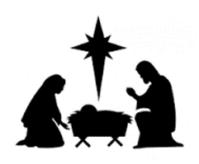
Not many high are here,
Not many holy;
Not many innocent children,
Not many worldly wise;
Not all familiar faces,
Not all frequent visitors.
But if tonight
Only strangers met,
That would be enough.

For Bethlehem was not the hub of the universe
Nor was the stable a platform for famous folk.

In an out of the way place
Which folk never thought to visit –
There God kept and keeps his promise;
There God sends his Son.

Taken from ‘Cloth for the Cradle’ Wild Goose Worship Group, Iona)
What if the Christmas Story Happened in Our Day?

What if the Christmas story happened in our day?
Mary and Joseph might well have been on the motorway.
Instead of a bright and guiding star,
Lights from car after car after car.

The night was foggy, wet and cold;
the bus in which they travelled was rickety and old.
Joseph was a worried man, full of fear,
for Mary, his beloved wife’s time was near.

He consulted the driver, a very kindly man,
‘Don’t worry mate’ he said, ‘I’ll do what I can’.
He left at the next exit and set them down
At the hospital in a very busy town.

The lady at the desk sadly shook her head,
‘Due to HSE cuts, I regret we have no bed.
Perhaps you could go private at the nursing home.
Joseph and Mary then began to roam.

Searching for shelter from door to door,
Just when time was running out and they could walk no more,
They came upon the shelter of a homeless group
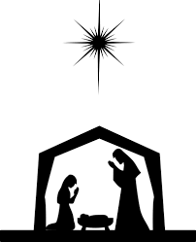
Who smiled at them and offered to share their soup.

The story is different, there’s not ass or ox.
This time the Son of Man lies in a cardboard box.

Sr. Julian Burrows.

1 Corinthians 3: The Christmas Version

By: Sharon Jaynes
If I decorate my house perfectly with plaid bows, strands of twinkling lights and shiny balls, but do not show love to my family, I’m just another decorator.
If I slave away in the kitchen, baking dozens of Christmas cookies, preparing gourmet meals and arranging a beautifully adorned table at mealtime, but do not show love to my family, I’m just another cook.
If I work at the soup kitchen, carol in the nursing home and give all that I have to charity, but do not show love to my family, it profits me nothing.
If I trim the spruce with shimmering angels and crocheted snowflakes, attend a myriad of holiday parties and sing in the choir’s cantata but do not focus on Christ, I have missed the point.
Love stops the cooking to hug the child. Love sets aside the decorating to kiss the husband. Love is kind, though harried and tired. Love doesn’t envy another’s home that has coordinated Christmas china and table linens.
Love doesn’t yell at the kids to get out of the way, but is thankful they are there to be in the way. Love doesn’t give only to those who are able to give in return but rejoices in giving to those who can’t.
Love bears all things, believes all things, hopes all things, and endures all things. Love never fails. Video games will break, pearl necklaces will be lost, golf clubs will rust, but giving the gift of love will endure.

