Christmas Carol Service

(With thanks to Paula Finnegan)

A carol service can be a lovely way to round off a busy term. It's also a key opportunity to re-introduce your students to the birth of Jesus and the true story of Christmas.

At Christmas people love tradition, so please give them some - traditional carols and readings that most will be familiar with. Equally, a new twist on familiar carols or bible readings can be really interesting so don’t be afraid to get creative either and use new ideas that your student cohort may have.

It can really add to the occasion if you can make the venue really welcoming whether it is in the school building or in the nearby Church. Decorations and fairy lights can really make a big difference. It is useful to have a copy of the service up on screen for people to see (esp the lyrics of the carols). If that’s not an option, a written copy of the carols is nice for your students to sing along to.

There are several carols included in this service. You may not have time to rehearse all of them with your students but you can use CD’s and/or YouTube clips of those songs if it makes life easier. Alternatively, you may choose to omit some of the suggested carols - sometimes less is more. You may decide to get each year group to sing their own carol, you may have a school choir or soloists to sing specific carols or you may wish it to be whole school from start to finish.

The preparation time you have available may vary depending on when in December your Christmas exams are held. If the school exams are held in early December, the Carol Service may be a good opportunity to focus on some faith formation. If your school exams are held later in December, you may not have as much time. Perhaps there is one year group (eg TY’s) who might be more available to prepare for this service with you.

Some teachers may like to get the students act out elements of the Christmas story instead of using the narrative solely provided in this template. There is opportunity for both if you wish. Carol Services can be as simple or elaborate as you wish. The main thing is that it is enjoyable and meaningful. The template below is very generic so please add/omit as suits you and your school community.

Most of all enjoy it, that’s what the story of Christmas is all about!

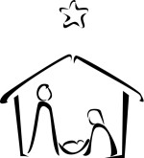

Introduction
Setting the scene - a student/students from the school/each year group can give a little introduction about the purpose of today’s carol service.

Opening Hymn - ‘O Little Town of Bethlehem’

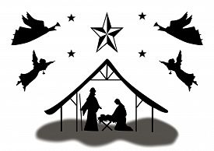
O little town of Bethlehem
How still we see thee lie
Above thy deep and dreamless sleep
The silent stars go by
Yet in thy dark streets shineth
The everlasting Light
The hopes and fears of all the years
Are met in thee tonight
For Christ is born of Mary
And gathered all above
While mortals sleep, the angels keep
Their watch of wondering love
O morning stars together
Proclaim the holy birth
And praises sing to God the King
And Peace to men on earth
How silently, how silently
The wondrous gift is given!
So God imparts to human hearts
The blessings of His heaven.
No ear may hear His coming,
But in this world of sin,
Where meek souls will receive him still,
The dear Christ enters in.
O holy Child of Bethlehem
Descend to us, we pray
Cast out our sin and enter in
Be born to us today
We hear the Christmas angels
The great glad tidings tell
O come to us, abide with us
Our Lord Emmanuel

Reader One

There once lived in the town of Nazareth, a young girl called Mary. One day God sent Gabriel the great angel, to give Mary some very important news.
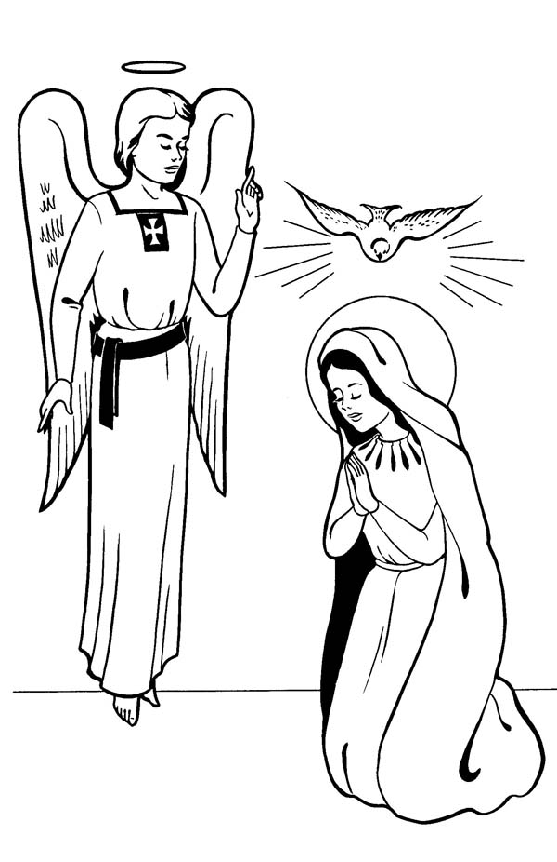

Luke 1:26-35
God sent the angel Gabriel to Nazareth, a town in Galilee. The angel said, “Greetings, you who are highly favoured! The Lord is with you.”
Mary was greatly troubled at his words and wondered what kind of greeting this might be. But the angel said to her, “Do not be afraid, Mary; you have found favour with God. You will conceive and give birth to a son, and you are to call him Jesus. He will be great and will be called the Son of the Most High. The Lord God will give him the throne of his father David, and he will reign over Jacob’s descendants forever; his kingdom will never end.”

Hymn No.2 – Silent Night

Oíche chiúin, oíche Mhic Dé,
Cách 'na suan dís araon,
Dís is dílse 'faire le spéis
Naoín beag gnaoigheal
ceananntais caomh
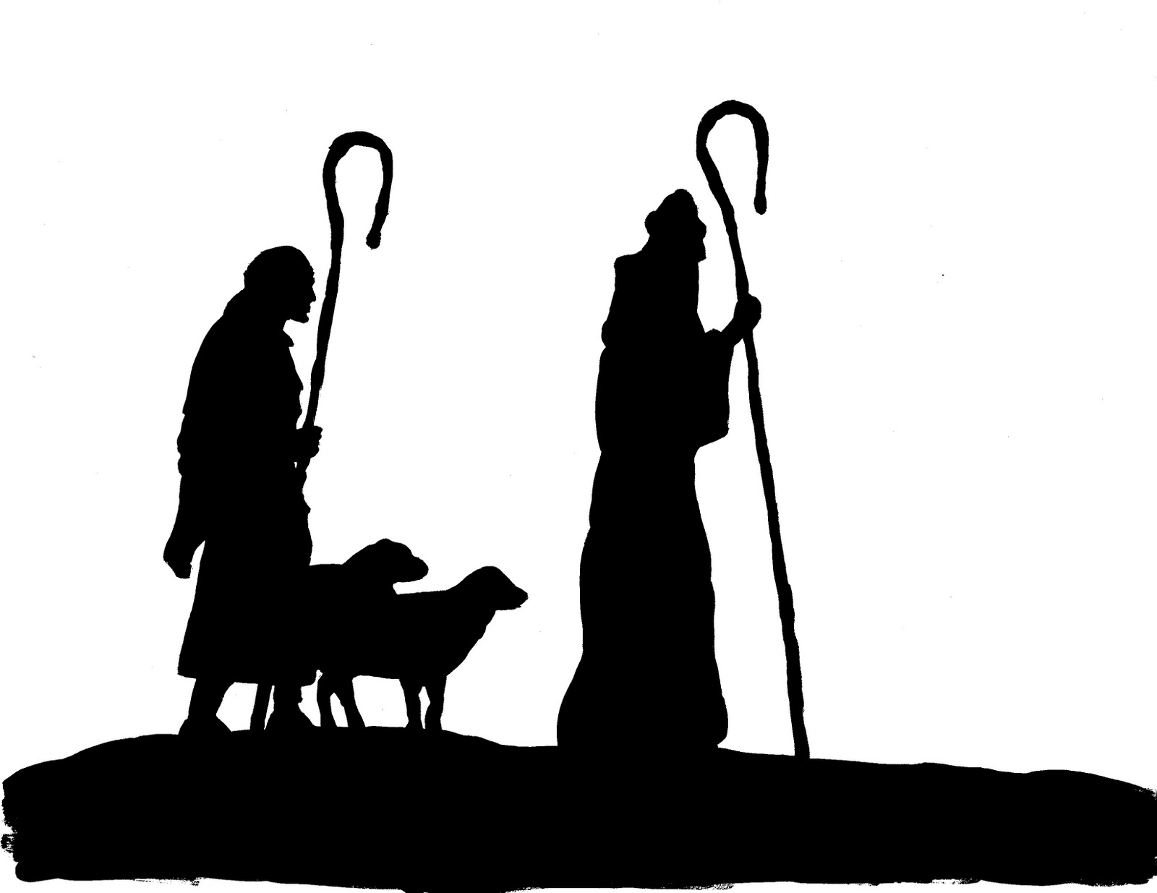
Críost, 'na chodhladh go séimh.
Críost, 'na chodhladh go séimh.

Silent night, holy night
All is calm, all is bright
Round yon Virgin Mother and Child
Holy Infant so tender and mild
Sleep in heavenly peace
Sleep in heavenly peace
Silent night, holy night!
Shepherds quake at the sight
Glories stream from heaven afar
Heavenly hosts sing Alleluia!
Christ, the Saviour is born
Christ, the Saviour is born
Silent night, holy night
Son of God, love's pure light
Radiant beams from Thy holy face
With the dawn of redeeming grace
Jesus, Lord, at Thy birth
Jesus, Lord, at Thy birth

Reader Two

As Mary and Joseph arrived in Bethlehem, Mary knew that her baby was about to be born but there was no room for them anywhere. All they were offered was a stable - that is where the son of God was born.

Luke 2:1-7
In those days Caesar Augustus issued a decree that a census should be taken of the entire Roman world. And everyone went to their own town to register.
So Joseph also went up from the town of Nazareth in Galilee to Judea, to Bethlehem the town of David, because he belonged to the house and line of David. He went there to register with Mary, who was pledged to be married to him and was expecting a child. While they were there, the time came for the baby to be born, and she gave birth to her firstborn, a son. She wrapped him in cloths and placed him in a manger, because there was no guest room available for them.

Hymn No.3 – Away In a Manger
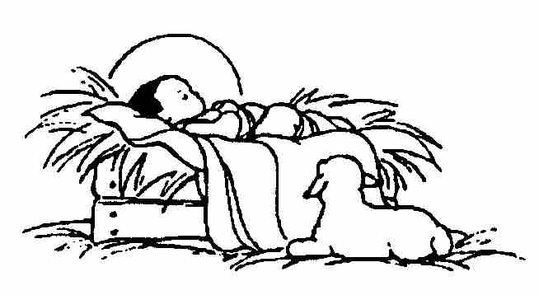
Away in a manger, no crib for a bed,
The little Lord Jesus lay down His sweet head.
The stars in the bright sky looked down where He lay,
The little lord Jesus asleep on the hay.
The cattle are lowing, the baby awakes
But little Lord Jesus, no crying He makes.
I love Thee, Lord Jesus, look down from the sky.
And stay by my side until morning is nigh.
Be near me, Lord Jesus, I ask Thee to stay
Close by me for ever and love me, I pray.
Bless all the dear children in Thy tender care
And take us to Heaven to live with Thee there.

Reader Three

That night some shepherds who were guarding their sheep near Bethlehem were startled by a great light in the sky. An angel came down and spoke to them.

Luke 2:8-16
And there were shepherds living out in the fields nearby, keeping watch over their flocks at night. An angel of the Lord appeared to them, and the glory of the Lord shone around them, and they were terrified. But the angel said to them, “Do not be afraid. I bring you good news that will cause great joy for all the people. Today in the town of David a Saviour has been born to you; he is the Messiah, the Lord. This will be a sign to you: You will find a baby wrapped in cloths and lying in a manger.”
Suddenly a great company of the heavenly host appeared with the angel, praising God and saying, “Glory to God in the highest heaven, and on earth peace to those on whom his favour rests.”
When the angels had left them and gone into heaven, the shepherds said to one another, “Let’s go to Bethlehem and see this thing that has happened, which the Lord has told us about.” So they hurried off and found Mary and Joseph, and the baby, who was lying in the manger.

Hymn No.4 – O Holy Night
O Holy Night
The stars are brightly shining
It is the night of our dear Saviour's birth
Long lay the world in sin and error pining
'Til He appeared and the soul felt its worth
A thrill of hope the weary world rejoices
For yonder breaks a new and glorious morn.
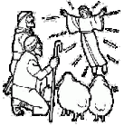
Fall on your knees O hear the angels voices.
O night divine O night when Christ was born
O night divine, O night, O night divine.
Led by the light of Faith serenely beaming,
With glowing hearts by His cradle we stand.
So led by light of a star sweetly gleaming,
Here came the wise men from Orient land.
The King of Kings lay thus in lowly manger;
In all our trials born to be our friend.
He knows our need, to our weakness is no stranger,
Behold your King! Before Him lowly bend!
Behold your King! Before Him lowly bend!

Reader Four

Meanwhile in his great palace in Jerusalem, jealous King Herod was talking to some Wise Men from the East. He had heard about the baby who had been born in Bethlehem and was terrified that one day this child would seize his throne.

Matthew 2:1-12
After Jesus was born in Bethlehem in Judea, during the time of King Herod, Magi from the east came to Jerusalem and asked, “Where is the one who has been born king of the Jews? We saw his star when it rose and have come to worship him.”

When King Herod heard this he was disturbed, and all Jerusalem with him. When he had called together all the people’s chief priests and teachers of the law, he asked them where the Messiah was to be born. “In Bethlehem in Judea,” they replied, “for this is what the prophet has written:
“‘But you, Bethlehem, in the land of Judah, are by no means least among the rulers of Judah; for out of you will come a ruler who will shepherd my people Israel.’”

Then Herod called the Magi secretly and found out from them the exact time the star had appeared. He sent them to Bethlehem and said, “Go and search carefully for the child. As soon as you find him, report to me, so that I too may go and worship him.”
After they had heard the king, they went on their way, and the star they had seen when it rose went ahead of them until it stopped over the place where the child was. When they saw the star, they were overjoyed. On coming to the house, they saw the child with his mother Mary, and they bowed down and worshiped him. Then they opened their treasures and presented him with gifts of gold, frankincense and myrrh. And having been warned in a dream not to go back to Herod, they returned to their country by another route.

Hymn No. 5 ‘We Three Kings’

We three kings of Orient are bearing gifts we traverse afar.
Field and fountain, moor and mountain, following yonder star.
O star of wonder, star of night. Star with royal beauty bright,
Westward leading, still proceeding, Guide us to thy perfect Light.
Born a king on Bethlehem's plain, Gold I bring to crown Him again,
King forever, ceasing never over us all to reign.
O star of wonder, star of night. Star with royal beauty bright,
Westward leading, still proceeding, Guide us to thy perfect Light.
Frankincense to offer have I, Incense owns a Deity nigh.
Prayer and praising all men raising, Worship Him, God on high.
O star of wonder, star of night. Star with royal beauty bright,
Westward leading, still proceeding, Guide us to thy perfect Light.
Myrrh is mine: it's bitter perfume breaths a life of gathering gloom.
Sorrowing, sighing, bleeding dying, Sealed in the stone-cold tomb.
O star of wonder, star of night. Star with royal beauty bright,
Westward leading, still proceeding, Guide us to thy perfect Light.

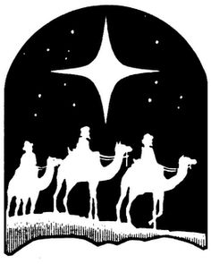
Glorious now behold Him arise, King and God and Sacrifice.
Alleluia, alleluia! Sounds through the earth and skies.
O star of wonder, star of night. Star with royal beauty bright,
Westward leading, still proceeding, Guide us to thy perfect Light.
The

Reader Five

The wise men followed the star and it guided them to Bethlehem and the place where Jesus lay. They were overjoyed to see the star there and went
straight into the stable. Out of their great store of treasures they gave the baby three very special gifts, gold, frankincense and myrrh.

These were very wise men and they were not fooled by King Herod. In
a dream they were warned by God to find a different way home. After a warning from God, Mary and Joseph fled to Egypt to escape from
Herod. When it was safe to do so they returned to live in Nazareth again.

Hymn No. 6 ‘Oh Come All Ye Faithful’

O Come All Ye Faithful
Joyful and triumphant,
O come ye, O come ye to Bethlehem.
Come and behold Him,
Born the King of Angels;
O come, let us adore Him,
O come, let us adore Him,
O come, let us adore Him,
Christ the Lord.
God of God, Light of Light,
Lo! He abhors not the Virgin’s womb.
Very God, begotten not created;
O come, let us adore Him,
O come, let us adore Him,
Christ the Lord.

Sing, choirs of angels,
Sing in exultation,
Sing all ye citizens of heaven above.
Glory to God, in the Highest;
O come, let us adore Him,
O come, let us adore Him,
O come, let us adore Him,
Christ the Lord.

Conclusion

This is an opportunity to conclude the message of the Carol Service. It may be delivered by a principal/teacher/student. If you are planning a lengthy Christmas Carol Service you could include a drama and/or focus on the advent wreath here as well.
