Feast Days in the Lenten Season

- The Feast of St Patrick March 17
- The Feast of St Joseph March 19
- The Feast of the Annunciation March 25

Instructions: On page 2 you will find the story of Saint Patrick’s life.

One night Patrick had a dream in which he heard a voice telling him to escape from Ireland and go home.

The raiders sold Patrick as a slave and he spent six years working as a shepherd.

Patrick came back to Ireland in 432. He told the people about God and God’s love for them.

Patrick was born in Britain. When he was sixteen years old, he was taken prisoner by a group of raiders and brought to Ireland.

Sometime later, Patrick had another dream, this one telling him to go back to Ireland and tell the people about God.

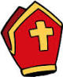
Patrick decided to become a priest and he was later ordained a bishop.

Patrick walked a long way to the coast, and managed to hide away on a boat that was going to Britain.

Patrick was very lonely during this time and he prayed to God every day and every night.

Cut out each of the pieces of the story and arrange them in the correct order. Take an A4 page and divide it into eight pieces by folding it in half three times. On each section of the page, draw a picture to represent each part of the story. When you are finished, cut your page into the eight sections, and shuffle your pictures around. Arrange your pictures in the shape of a cross, so that everyone will know that Saint Patrick came to bring the Good News about God to Ireland.
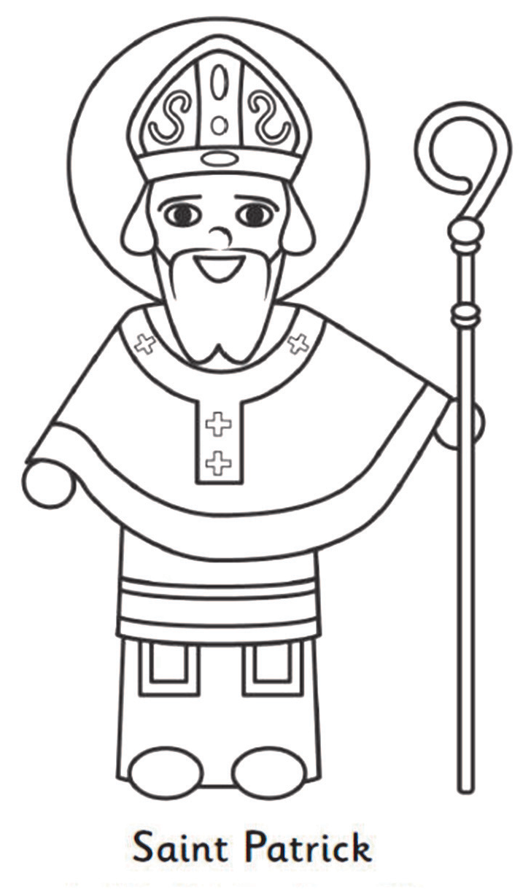
On March 17 each year, we celebrate St Patrick’s Day. The Word Bank will help you to fill in the blanks and tell the story of how St Patrick came to be Ireland’s Patron Saint

St Patrick was born in many years ago. When he was just a young boy, he was captured and taken to ____________where he was sold as a slave to a farmer. Patrick’s job was to mind _____________. The farmer didn’t look after Patrick very well. He was often very ___________ and ate the same food as the sheep and pigs.
He ______________ to God every night. God was his best friend. Then one night he heard a _____________. It was God. God told him to escape and to go back to Wales. Patrick was very happy to go home and he decided to do God’s work and become a __________. Then he had a ______________ that God wanted him to go back to _______________ and tell the people all about how much God _________ them. Patrick didn’t want to go, but he knew it was the thing to do. When Patrick came back to Ireland, he used the _____________ to tell the people about God – the ____________, the_____
and the Holy ______________.

Word Bank
Son voice hungry Wales animals
Prayed Ireland Spirit dream priest
Father loved Ireland right shamrock

Sacred Sites of St. Patrick in Ireland

Lough Derg, Co. Donegal:
Legend has it that St. Patrick had a vision of the afterlife while in a cave on an island in Lough Derg in Co. Donegal. Other Irish saints like St. Daveoc also visited the island, and it became a place of pilgrimage. Today people travel during the summer months for three days of fasting, and praying giving up their sleep and their shoes and socks!! You can find out more about this island by visiting www.loughderg.ie where you can see images of the island as well as reading about people’s personal experiences of the island.

Slane, Co. Meath:
After Patrick had escaped and left Ireland he had a dream in which he was told to return to Ireland. In the dream the angel told him to return and tell the people the good news about God. Patrick trained as a priest before his return. When he did return in the year 432 AD, he lit the first Easter fire on the Hill of Slane.

The Rock of Cashel
The Rock of Cashel is in Co Tipperary. It is also known as St Patrick’s Rock, Carraig Phádraig. It was here that Patrick is said to have baptised Aenghus, the King of Munster in the 5th Century.
You can find more information at www.cashel.ie

Croagh Patrick, Co. Mayo
Croagh Patrick, overlooks Clew Bay in County Mayo, and it is considered the holiest mountain in Ireland. In 441 AD Patrick spent 40 days fasting on the top of this mountain. Each year about 1 million pilgrims climb Croagh Patrick. On 'Reek Sunday', the last Sunday in July, there are over 25,000 pilgrims on the mountain. For more information and pictures see www.croagh-patrick.com

To Do
Find all these places on a map of Ireland
Find out more about these and other sites associated with St Patrick
Compile a Fact File on one Sacred Site
Find out if there is anywhere in your parish that is associated with St Patrick or any other saint.

Lá Fhéile Pádraig 17^{ú} Márta
- Céiliúirimid Lá Fhéile Pádraig ar an 17ú Márta gach bliain
- Is é Naomh Pádraig patrún na hÉireann
- Deirtear gur rugadh Naomh Pádraig sa bhliain 385 AD sa Bhreatain Bheag – áit dar ab ainm Banwen.
- Ag aois a sé mbliana déag, gabhadh Naomh Pádraig agus díoladh mar sclábhaí é le feirmeoir caorach.
- D’éalaigh sé nuair a bhí sé dhá bhliain is fiche agus chaith sé an chéad dhá bhliain déag eile i mainistir.
- Nuair a bhí sé sna tríochadaí d’fhill sé ar Éirinn mar misinéir.
- D’úsáid Naomh Pádraig an tseamróg chun a mhíniú do dhaoine faoin Tríonóid Naofa, sé sin go bhfuil triúr duine in aon Dia amháin – an tAthair, an Mac agus an Spiorad Naomh.
- Fuair Naomh Pádraig bás i Saul sa bhliain 461 AD agus cuireadh é i nDún Pádraig i gCo. an Dúin.
- Ceiliúrtar cultúr agus stair na hÉireann ar fud an domhain uilig ar Lá Fhéile Pádraig.
- Is lá saoire poiblí é Lá Fhéile Pádraig anseo in Éirinn ach an raibh a fhios agat gur ionainn an scéal i ndhá cheantair i gCeanada – Newfoundland & Labrador.
- Seo thíos iomann a chanaimid in onóir do Naomh Pádraig.
Dóchas Linn Naomh Pádraig

Dóchas linn Naomh Pádraig Sléibhte gleannta maighe
Aspal mór na hÉireann 's bailte mór' na hÉireann
'Ainm oirirc gléigeal Ghlan sé iad go deo dúinn
Solas mór an tsaoil é Míle glóir dár Naomh dhil
'S é do chloígh na draoithe Iarraimid ort, a Phádraig
Croíthe dúra gan aon mhaith Guí orainne Gaela
D'ísligh dream an díomais Dia linn lá 'gus oíche
Tré neart Dé ar dtréanfhlaith ‘s Pádraig Aspal Eireann

St Joseph’s Day March 19
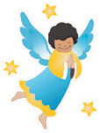
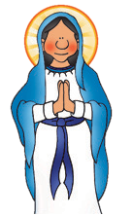
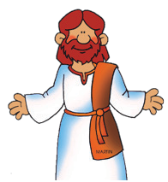
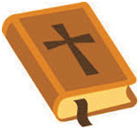
How much do you know about St Joseph? Draw a line to the picture to finish the sentence. Then rewrite the full sentences underneath.

Joseph was married to…

- Joseph was foster-father to…

- Joseph worked as a…

- Joseph was related to David, who was a…

- We find out about Joseph in the…

- In a dream, Joseph heard the voice of an…

Joseph looked after Jesus and helped Mary to mind him.
That is why St Joseph is the patron saint of fathers.
Say a prayer to St Joseph today. Ask St Joseph to bless your Daddy,
or whoever helps to mind you like Joseph helped Mary.
Make sure to say thank you to that person today. Tell him that you asked St Joseph to bless him.

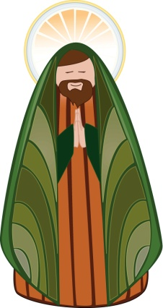
Feast of St Joseph March 19

St Joseph protected and cared for Mary and Jesus during his life with them. St Joseph is the patron saint of fathers and of workers.

Today let us remember our daddies, our granddads, our uncles and all those who care for us.
We give thanks for St. Joseph and the love he shared and the care he gave to Mary and Jesus. Amen

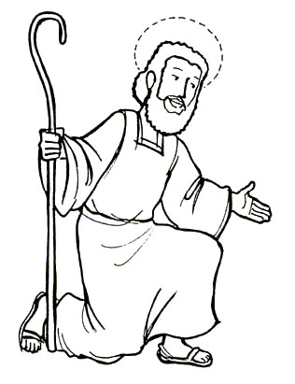

St Joseph Pray for Us

The Feast of the Annunciation March 25

Use the word bank below to help you complete the following sentences
from the gospel story

1: You are truly !

2: The Lord is with you. Do not be ________________!

3: God is with you, and you will have a________.
4: His name will be .
5: He will be and will be called the Son of the Most-High.

6: Then God will make him a ____________, as his ancestor was.

7: He will ___________the people of forever, and his will never end.

8: I am the Lord’s ! Let it ___________as you have said”

Pleased God
Blessed Jesus
David
Servant
King
Son
Kingdom Israel
Great
Rule
Happen
Afraid

The Feast of the Annunciation March 25
This is adapted from Luke 1:26-38. You can also read it in the class bible.
In the city of Nazareth, in Galilee, there lived a young woman named Mary. Mary was soon to marry a carpenter named Joseph. One day an angel called Gabriel visited Mary and said ‘Greetings, most favoured one, and do not be afraid. God has chosen you among all women. Very soon you will have a baby, you must call him Jesus.’ This was to be a very special baby. He would be great, and his kingdom would last forever. He told her that the child would be called Son of God. Mary was very afraid but Gabriel told her not to be. He said that the Holy Spirit would fill her and would give her courage and strength. Mary bowed before the angel Gabriel and told him that she would do as God wished. When she got up the Angel had gone. After receiving this news, Mary heard that her Cousin Elizabeth was also going to have a baby and she went to visit her. When she reached the house of Elizabeth the two women praised God and Mary sang these words.
My soul proclaims the greatness of the Lord,
my spirit rejoices in God my Saviour;
He has looked with favour on his lowly servant.
From this day all generations will call me blessed;
The Almighty has done great things for me and holy is his name.
He has mercy on those who fear him,
from generation to generation.
He has shown strength with his arm
and has scattered the proud in their conceit
Casting down the mighty from their thrones
and lifting up the lowly.
He has filled the hungry with good things
and sent the rich away empty.
He has come to the aid of his servant Israel,
to remember his promise of mercy,
The promise made to our ancestors,
to Abraham and his children forever.

Feast of the Annunciation March 25

The Angelus Bell Calls us to Pray

Every day at 12.00 noon and 6.00pm the Church Bell announces the Angelus. We hear it on RTE radio and television. We have been praying the Angelus for a very long time, about 700 years. It reminds us of when God sent the Angel Gabriel to Mary. The angel told Mary that she was to become a mother and that the baby would be the Son of God. The prayer also helps us to remember and say thanks that Mary said ‘yes’ and did what God had asked her to do.

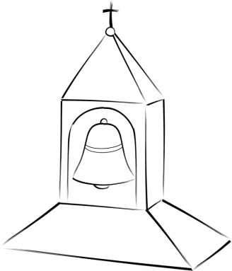

The Angelus Prayer
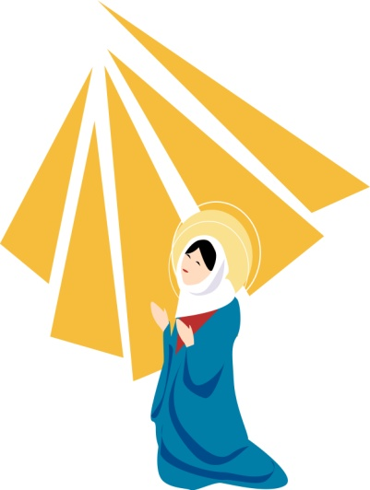
V. The angel of the Lord declared unto Mary.
R. And she conceived by the Holy Spirit.
Hail Mary, full of grace…
V. Behold the handmaid of the Lord.
R. Be it done unto me according to thy Word.
Hail Mary, full of grace…
V. And the Word was made flesh.
R. And dwelt among us.
Hail Mary, full of grace…
V. Pray for us, O Holy Mother of God.
R. That we may be made worthy of the promises of Christ.
Let us pray: Pour forth, we beseech thee, O Lord, thy grace into our hearts, that we to whom the incarnation of Christ thy Son was made known by the message of an angel, may by his passion and cross be brought to the glory of His resurrection; through the same Christ our Lord. Amen

