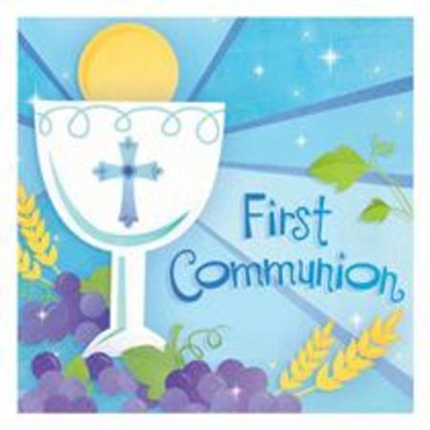
Preparing to Celebrate Sacraments
Diocese of

PARISH: __________________________

Dear Parent/Guardians of children preparing to celebrate First Holy Communion/Confirmation

To help us best prepare for First Holy Communion/Confirmation celebrations in 2021 we need to ensure that we have up to date contact details for all our families. This will help us to keep in touch with you and to consider how we can prepare together to celebrate these sacraments. Please complete both sides of this form and return it to _________________________ on or before _____________________.

Contact Information

Name of Child: ________________________________________________

Date of Birth: ________________________________________________

Parish of Baptism: _______________________________________________

Primary School: _________________________________________________

I/We wish to register _________________ for preparation for (please tick which sacrament)
(child’s name)

First Holy Communion
Confirmation

I/We look forward to hearing from the parish about opportunities to be involved in preparation for this sacrament.

Parents/Guardians: _____________________________________________

If your child was baptised outside of this parish and you have not yet provided a copy of their baptismal certificate to the parish, please include a copy with this form.

Contact Details
Father’s Name
Mother’s Name:
Family Contact Mobile Number:
Family Contact E-mail address

Family Postal Address

We will continue to do our best to support and prepare _____________ to celebrate the sacrament/s of Eucharist/Confirmation. (child’s name)
I/We furthermore consent to the information on this application form being used by the parish of _______________ in order to contact us about sacramental preparation and celebration, subject to the relevant General Data Protection Regulations.
Please note: Family contact mobile number and email are required to ensure the parish can maintain effective and timely communication with you as may be necessary.
Privacy Notice and Data Protection Consent
The information is this form will be used by the parish of [insert name of parish] to facilitate the celebration of your child’s First Holy Communion/Confirmation. The parish of [insert name of parish] is the data controller for the data you provide on this form and can be contacted at: [insert address of parish]. The form will be destroyed within 12 months of your child’s First Holy Communion/Confirmation. By signing this form, you consent to the parish of [insert name of parish] collecting and processing the data on the form as outlined.

Please return this form (and copy of Baptismal Certificate, if required) to _____________________ (Give details: e.g. postal address/as a saved word document/google docs/drive attachment via parish email address, etc.) by insert date.

Signed: ___________________________ _______________________________
Parent(s) / Guardian(s)

