 | I ns e r t P a r i sh N a m e
Sacramental News
Insert Name of Priest/ Sacramental Coordinator |  | Insert Contact details
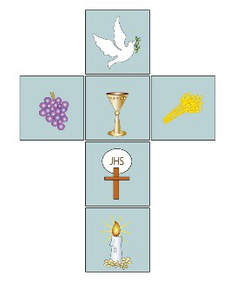  A Word of Welcome  Introduce yourself and others who will be making contact with families preparing for sacraments  Say a little about your hopes for the year ahead  How you will be making contact | Making a Family Prayer Space  As the season of Advent begins, find a place for a Family Prayer Space, This can be a reminder for all the family that this is a special year, not just for the child who is preparing to celebrate First Holy Communion or Confirmation but for everyone who will accompany them on this journey. The video. ‘Creating a Family Prayer Space’, made by Newbridge parish https://www.kandle.ie/preparing-to- celebrate-sacraments-with-children- in-2021/ will help you in this task. You might like to take a photo of your Family Prayer Space and send it to insert email address for parish here | Advent Wreath  You might like to include an  Advent Wreath in your Family Prayer Space.  Have a look at  the video from Naas Parish on https://www.kandle.ie/preparing-  to-celebrate-sacraments-with- children-in-2021/ and start a new tradition for Advent this year. You will also find an Advent Wreath to colour, the story of the Advent Wreath, a simple Advent Wreath to make for smaller children and some prayers for each week of Advent on https://www.kandle.ie/preparing- to-celebrate-sacraments-with- children-in-2021/
 | A Prayer of Blessing for your Advent Wreath  Loving God  let your blessing come upon us as we place this wreath in our Family Prayer Space.  May the candles we light be a sign of hope for us as we wait for the coming of the Christ child this Christmas time.  We make our prayer through Christ our Lord. Amen | Think About  Lighting a candle/s on your Advent Wreath or in your Family Prayer Space and saying a prayer together before bedtime  Trying out some of the activities for Advent on https://www.kandle.ie/preparing- to-celebrate-sacraments-with- children-in-2021/
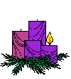

• • • •
• • • •

Sa c r a m e n t al News
• • • • • • • • • • • • • • • • • • • • • • • • • • • • • • • • • • • •
• • • • • • • • • • • • • • • • • • • • • • • • • • • • • • • • • • • •

-

