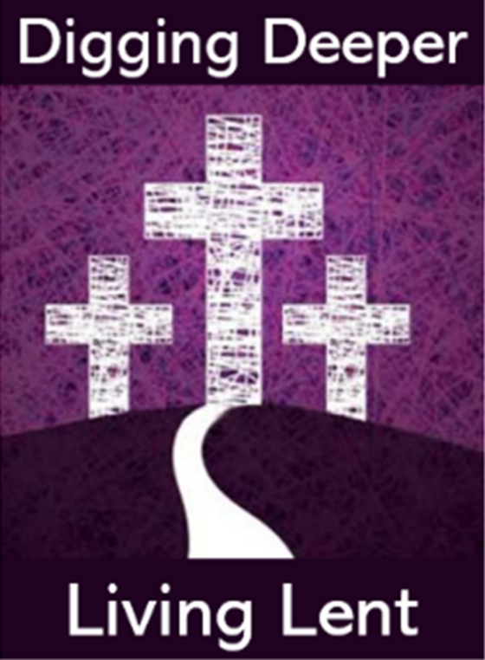
Ministry Update: Lent 2020

A Newsletter for Clergy, Parish Sisters and Staff, and all those involved in ministry in the parish,
from Kildare and Leighlin Faith Development Services.

059 9164084 / fds@kandle.ie February 2020

Lenten Catechesis for all:
Digging Deeper – Living Lent
A series of five weekly bulletins, along with a suite of other resources, is being made available to parishioners across the diocese this Lent.
The bulletins will be available through the parish but can also be accessed on kandle.ie
Coming in the season of Lent, when we are preparing ourselves to renew our baptism at Easter, the bulletin focuses on a number of primary areas:
Looking to the Rite of Baptism: By exploring what we do, say and pray in our celebration of baptism we can re-discover the meaning of our baptism and how we are called to live as baptised members of the Church in the world.
Linking with the Sunday Gospel: The Gospels of Lent accompany, guide and inspire us as we make our journey in Lent. They can be key tools for helping us to review our lives in the light of our faith and turn back to God.
Exploring a Lenten Practice: Each bulletin briefly explores a particular aspect or practice for Lent, for example Stations of the Cross, works of Mercy, celebrating the Sacrament of Penance and Reconciliation. Reference is also made to resources for these exercises on kandle.ie.
Digging Deeper – Living Lent: Some Suggestions for the week: Alongside the Lenten resolutions that people will have chosen for themselves, each bulletin will offer additional suggestions that people might like to take on board as part of their Lenten journey.
The following resources are available on kandle.ie as part of
Digging Deeper – Living Lent

A letter of Invitation from Bishop Denis
*Five weekly bulletins (2 page A4)
*Six weekly scripture sharing reflections
Suggestions for Sacred Spaces in the church
Lenten Prayer of the Faithful
Diocesan Rosary Prayer Cards
Diocesan Guide to Confession
Poster on the Works of Mercy
Trócaire’s guide to praying the Stations of the Cross
Diocesan Stations of the Cross for our times *These will be uploaded weekly on kandle.ie

Regulations for Fasting in Lent
As Catholics we are asked to abstain from meat and to fast on two days in the year, Ash Wednesday and Good Friday. Fasting means that one full meatless meal can be eaten in the day. Two other meatless meals may be taken to maintain strength but together they should not exceed one full meal. Liquids, including milk and fruit juice, may be taken between meals. The fasting regulation applies to all Catholics aged 18 to 59 while those aged fourteen and above are asked to abstain from meat. Some people are not required to fast; these include those who are sick, pregnant or nursing women and manual labourers according to need. In the past, Irish Catholics were required to abstain from meat every Friday. While still not a requirement, the Irish Bishops’ Conference has suggested it as a form of Friday Penance during Lent.

Have you recently changed your email address? If so, please remember to let us know to ensure that you continue to receive correspondence, such as this one, from us.

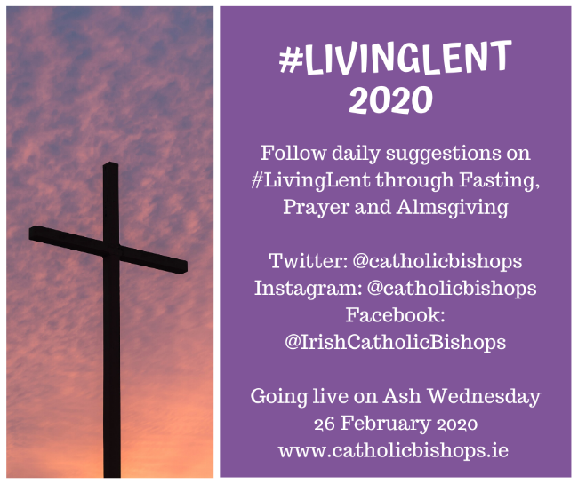
If you need us to update your details please contact Christine at fds@kandle.ie
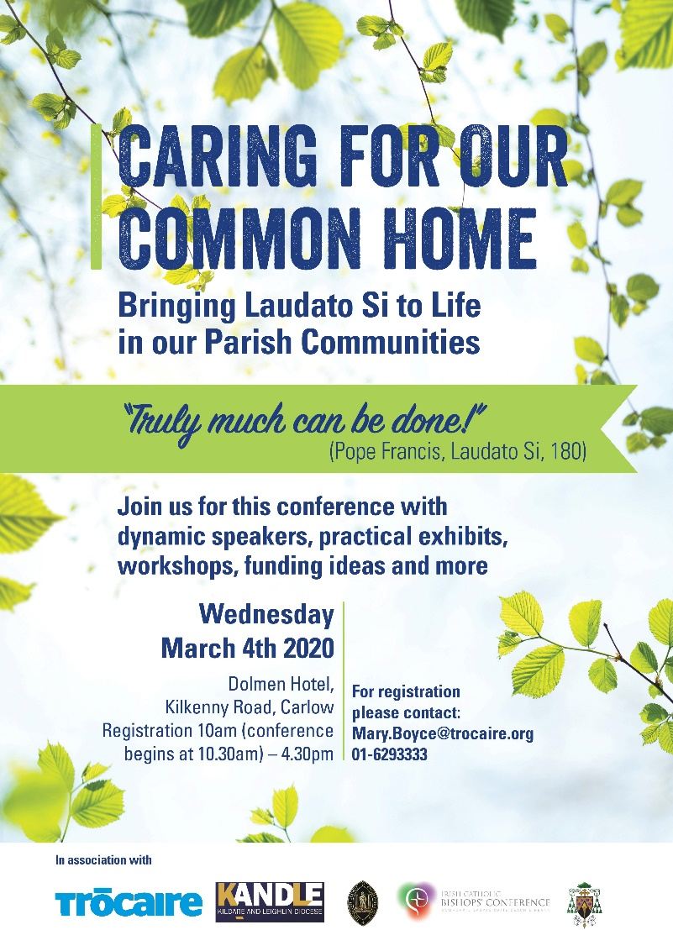
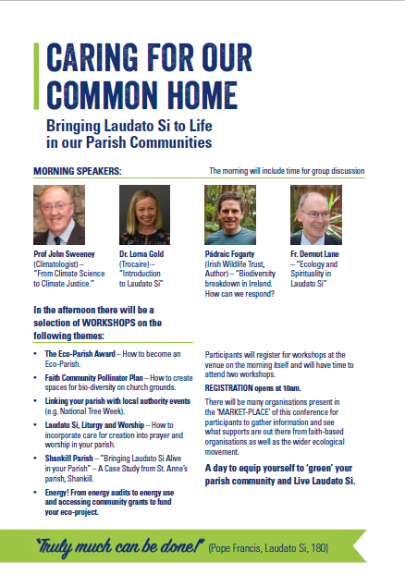
Don’t miss out! Book your place as soon as possible!
Diocesan Choir
Music Rehearsal

The music rehearsal for the Chrism Mass will take place in Carlow Cathedral on Saturday, March 28th from 11:00 am-1:30 pm

If you are intending being part of the choir and have not yet received the music by email, please contact Christine at fds@kandle.ie

Chrism Mass 2020
Bishop Denis warmly invites parishioners from across the diocese to join him and the priests of the diocese in celebrating the Chrism Mass in the Cathedral on Monday, April 6 at 7:30 pm.
The Chrism Mass is a wonderful diocesan celebration in which the bishop blesses and consecrates the holy oils for use in parishes in the year ahead.

Please come early to be sure of a seat!

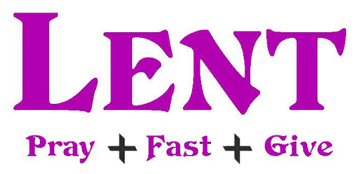

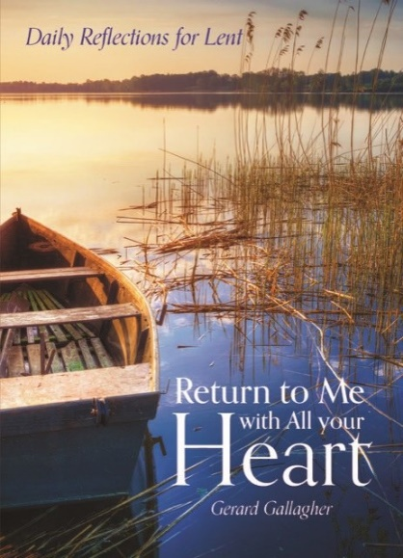
A Book Choice for Lent

Return to Me with All your Heart is a thought-provoking selection of scripture readings and reflections designed to accompany the reader through the season of Lent. This accessible and practical guide, which also includes inspirational quotations and questions to prompt the reader to effect change in their day-to-day lives, is the perfect companion for this essential period in the Church calendar.
ABOUT THE AUTHOR:
Gerard Gallagher works as a pastoral coordinator in the Archdiocese of Dublin and is a parishioner in Two-Mile-House, Co Kildare.

AVAILABLE FROM VERITAS €7.99
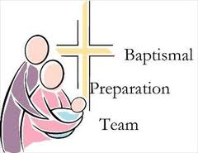
Gathering for Parish Baptism Teams and Parish Clergy
with Bishop Denis and Commission for Liturgical Formation

Baptism teams and parish clergy and staff are very welcome to join with Bishop Denis
and the Commission for Liturgical Formation on Thursday, April 30, 2020 at 7:30 pm in Mount St Anne’s, Killenard, Laois.

This night will be a combination of input and consultation as we look to the preparation of families and the celebration of baptism in our diocese. We will be joined by Fr Damian McNeice of the Archdiocese of Dublin.
Bookings now being taken at fds@kandle.ie / 0599164084.
Please leave name of parish, contact person and # attending.

Di Diocesan Pastoral Council News: Five Key Themes Under Exploration

Together with Bishop Denis, the Diocesan Pastoral Council has
identified five key themes on which it intends to focus. It is hoped
to engage with parishes and diocesan bodies in the coming months
to bring these themes to a concrete expression within the diocese.
The identified themes, not in any order of priority, are as follows:
1. Sharing the Good News of our Faith and communicating the Gospel Message
2. Getting to know the person of Jesus and our Catholic faith through life-long faith formation
3. Reaching out and being present to all
4. Liturgies that lift up our hearts, inspire and energise us to lead a Christian life
5. Animating and supporting parishes in shaping a new reality and greater involvement

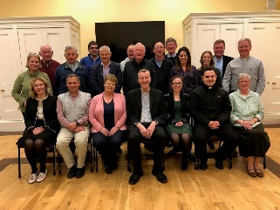

This Lent Trócaire is focusing on two families, one in Kenya and one in Honduras, to highlight how mothers work to protect their families and communities from the devastating impact of climate change and from the actions of corporations. Madris, in Kenya, and Angela, in Honduras, are two such women. We think of them and women like them all over the world this Lent.

See trocaire.org/resources/parishes/lent for Lenten resources for the parish including Stations of the Cross, homily notes, exploring the Gospels with children, prayers and reflections.
Please give generously to Trócaire
this Lent.
Sunset on
Holy Saturday,
April 11

8:21 p.m.
We are called to begin the Easter Vigil in darkness around the Easter fire.
Sunrise on
Easter Sunday,
April 12

6:35 a.m.
Short Introductory Videos
to the Liturgies of the Triduum
Liturgy group members might find it useful to watch the following short videos from iCatholic.ie before they begin to actively prepare the liturgies of the Triduum.

- An introduction to the Triduum
- Celebrating the liturgies of the Triduum: Holy Thursday
- Celebrating the liturgies of the Triduum: Good Friday
- Celebrating the liturgies of the Triduum: Easter Vigil

To find the videos, from the ICatholic.ie home page, go to ‘Select Category’ and click on ‘liturgy’.

Resources for Lent and the Easter Triduum
Alongside ‘Digging Deeper, Living Lent’, check out the many resources available on kandle.ie for journeying through and celebrating Lent and the Easter Triduum.

Data Protection If you no longer wish to receive this newsletter or similar correspondence from Faith Development Services, please contact Christine at fds@kandle.ie

