Gatherings for Incoming Chairpersons
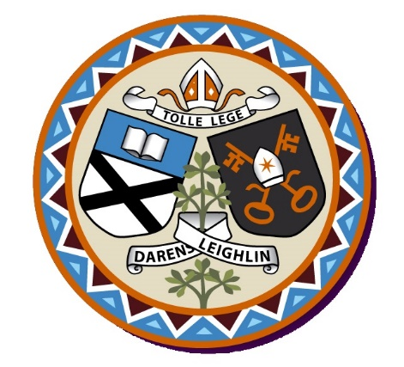
of Boards of Management 2019-2023

Diocese of Kildare & Leighlin

5 November Keadeen Hotel, Newbridge

6 November Mt St Anne’s

12 November Seven Oaks Hotel, Carlow

Each Session will begin at 7 with light refreshments and conclude at 9:30p.m.

Please book your place by emailing maeve.mahon@kandle.ie or phoning
059 9164084

