Diocesan Scripture Sharing Groups –

Advent 2018

ScriptureSharing
‘
Discerning and Responding to God’s Presence in our Lives!’

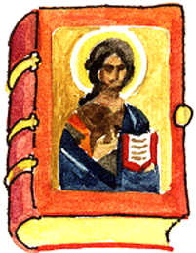

Kildare & Leighlin Faith Development Services,
Cathedral Parish Centre, College Street, Carlow
Tel: 059-9164084 Email: fds@kandle.ie

********************************************************

ORDER FORM

Please complete and return this Order Form before Friday, 23rd November, to:
Christine Oglesby, Kildare & Leighlin Faith Development Services,
Cathedral Parish Centre, College Street, Carlow

I _require Advent Booklets @ €2.50 each + p.p.

Delivery Instructions

Post to ________________ ____________________________________________________________________

Will collect ____________________

