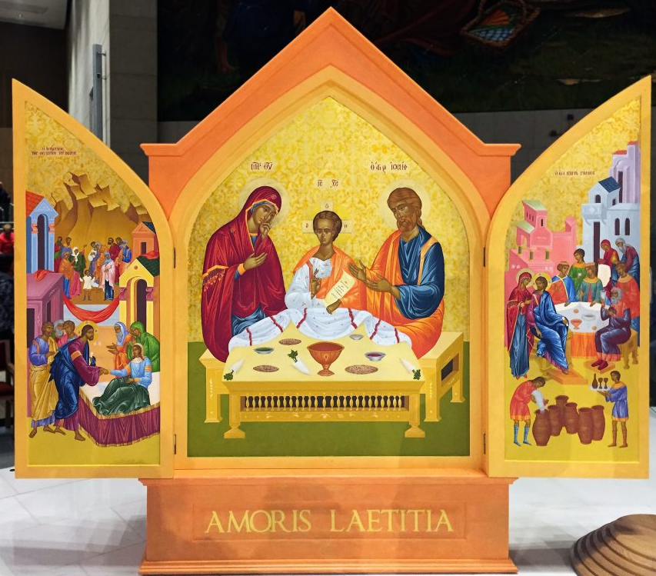  January 17  Kildare & Leighlin Launches  Catholic Schools Week 2018  A Diocesan Celebration of Catholic Education  This is the first time that we will officially launch Catholic Schools Week with a celebration in the Diocesan Cathedral in Carlow. As part of our launch we are asking all our schools to make a Prayer Petition Box for their School Prayer Space and bring it to the Cathedral on January 17. Bishop Denis will bless the boxes and present each school with a copy of the Icon of the Holy Family for their School Prayer Space.  Catholic Schools Week is now firmly established in the life of our schools and this year it has an added dimension as we prepare for an important event in the life of the Universal Church, The World Meeting of Families. This will take place in Dublin in August 2018.  As part of the preparation a specially commissioned Icon of the Holy Family will travel around the country raising awareness and inviting people to pray. The Icon will arrive in our diocese in May 2018 and its visit, to Newbridge, Portlaoise and Carlow, will we hope, be an opportunity for prayer and thanksgiving for us all. One aspect of the Icon’s visit will be an invitation to place prayers of petition in our Diocesan Petition Box. Our petitions will then be held in prayer by members of Religious Communities all over the diocese.  Over the coming months prayers can be placed in the Petition Box by children, staff and parents. In May, each school will be invited to bring their box of prayers and place it in front of the Icon when it visits their local area.  You decide what size your Prayer Petition Box should be, how it might be decorated and which class or group of students might be given the important task of creating it. | Cathedral of the Assumption, Carlow  Wednesday,  17 January  12:00 – 1:00  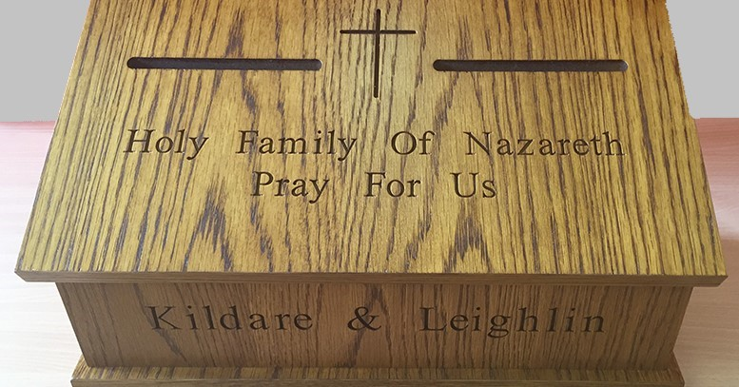  ────  Bring your School Prayer Petition Box  ────  5 representatives from each Primary & Post-Primary school and we will have a packed Cathedral  ────  Bishop Denis will lead us in prayer  ────  An opportunity to celebrate the gift that is our Catholic Schools  www.kandle.ie  Telephone  Web Address  Dates and Times

