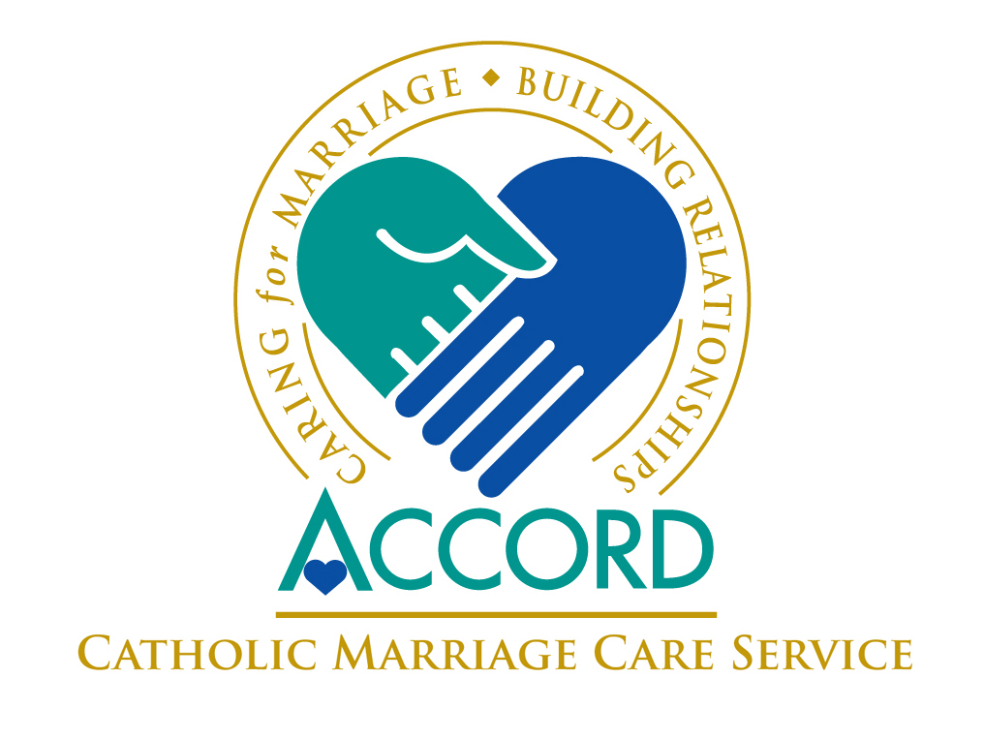

ACCORD invites applications for the

Certificate in Counselling (Marriage and Relationship)

for the academic year 2017/2018.

The Certificate, validated by St. Patrick’s College Maynooth, is aligned to Level 8, 20 ECTS on the National Framework of Qualifications and is aimed at qualified, experienced counsellors/psychotherapists who have:
- Degree/Diploma in Counselling/Psychotherapy
- Completed a min of 200 client hours and have a current caseload
- Knowledge/experience of the Person Centred Approach

Successful applicants’ course and supervision fees paid by ACCORD

Training in Maynooth one weekend per month, September to June
Application Criteria and Form:
http://www.accord.ie/joining-accord/becoming-a-counselor

Closing date: 15th May 2017

Please contact the ACCORD offices in the Kildare & Leighlin diocese:
CARLOW accordcarlow@eircom.net 059 9138738
NEWBRIDGE accordnewbridge@eircom.net 045 431695
PORTLAOISE accordportlaoise@hotmail.com 057 8661581
for further information.

ACCORD - 55 centres Nationwide.
More information is available on: www.accord.ie

