Kildare & Leighlin Post-Primary
Religious Education

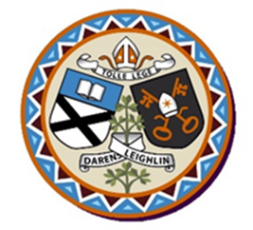

Annual Seminar for Religion Teachers
(Inter Diocesan)

Tuesday
10th October 2017

Hotel Kilkenny
9.30am—3.30pm.

9.30 am: Registration

9.45 am: Welcome and Prayer

10.00 am: Dr. Martin Fitzgerald: Education for
Transformation; The Courage to Teach.

11.15 am: Coffee Break.

11.30 am: Fr. Paddy Byrne – Challenging Times.

12.00 pm: Kate Liffey – National Director for Catechetics:
Religious Education and the New Junior Cycle Framework.

12.45 pm. David Kennedy: Catholic Schools Week and the
World Meeting of Families 2018.

1.00 pm: Lunch

2.00 pm: Jonny Somerville: NUA

Introducing an inspiring new resource from Scripture Union which seeks to open up discussions around faith with young people, the questions they may have, their searchings and longings.

3.10 pm: Concluding Meditation.

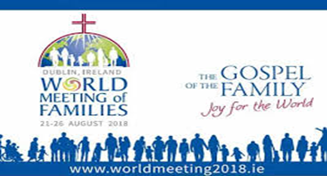

The Presenters

Dr. Martin Fitzgerald is a Lecturer in Education and Human Development at the Limerick Institute of Technology, Tipperary Campus, Thurles He has worked as a teacher in both second and third level and has a particular interest in educational philosophy, assessment and development education.

Fr. Paddy Byrne is a priest in the Diocese of Kildare and Leighlin and has been chaplain in a variety of post-primary schools. He writes a weekly column for the Carlow Nationalist, produces a weekly blog on the parish website and has a wide following on Twitter - all testament to his gift for communication across the generations.

Kate Liffey is the National Director for Catechetics.
Before taking up this position she taught Religious Education and History for ten years; she has worked with the Edmund Rice Schools’ Trust supporting teachers in both primary and secondary schools and also held the position of Church Outreach Officer with Trocaire.

David Kennedy is a researcher for the CSP, ATCS, CPSMA, and WMOF 2018. He lectures part-time at DCU and Hibernia College and is a PhD candidate at the Institute of Education, DCU.

Jonny Somerville is a married man with 4 children who has worked with Scripture Union Ireland for more than ten years. He is passionate about faith development and his experiences have shown him that young people often struggle to discuss their doubts. For this reason, he has recently co-written and produced NUA, an 8 part film series that encourages questions, acknowledges doubt, and offers an engaging perspective on the Christian faith

Please return your names on the enclosed form with
payment by

Wednesday 27th September 2017

to:

Kildare & Leighlin Faith Development Services
Cathedral Parish Centre
College Street
Carlow
Co. Carlow

Cost: €60 per person (in advance)

All cheques must be made payable to:

Kildare & Leighlin Services

If you wish to pay by electronic payment, please
contact Christine, email fds@kandle.ie
or phone (059) 916 4084 for bank details

